English Grammar – Adjectives

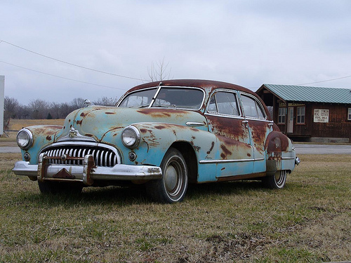 | 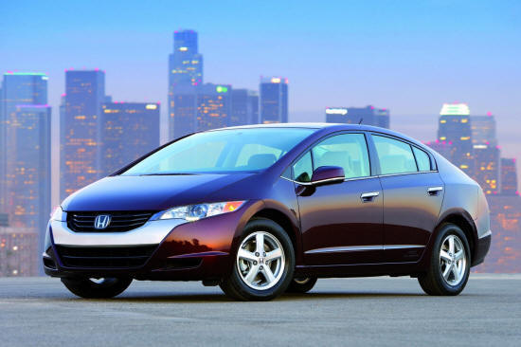 | 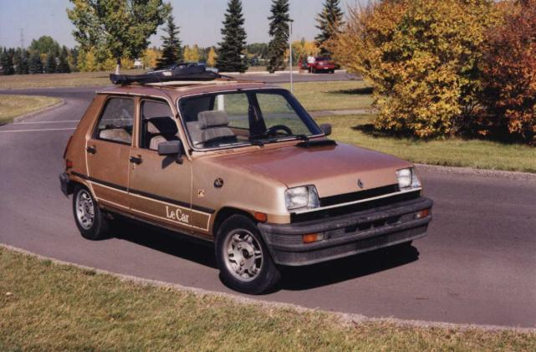 | 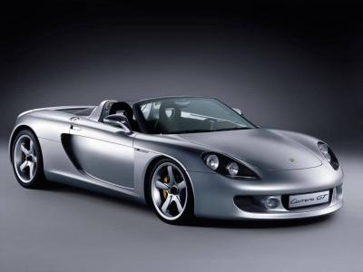
1. Old | 2. New | 3. Cheap | 4. Expensive
 |  |  | 
5. Clean | 6. Dirty | 7. Good | 8. Bad
 |  | 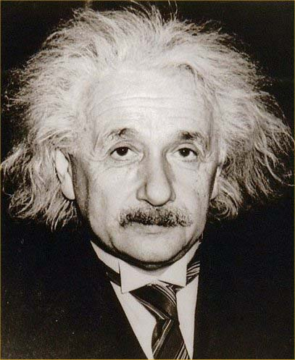 | 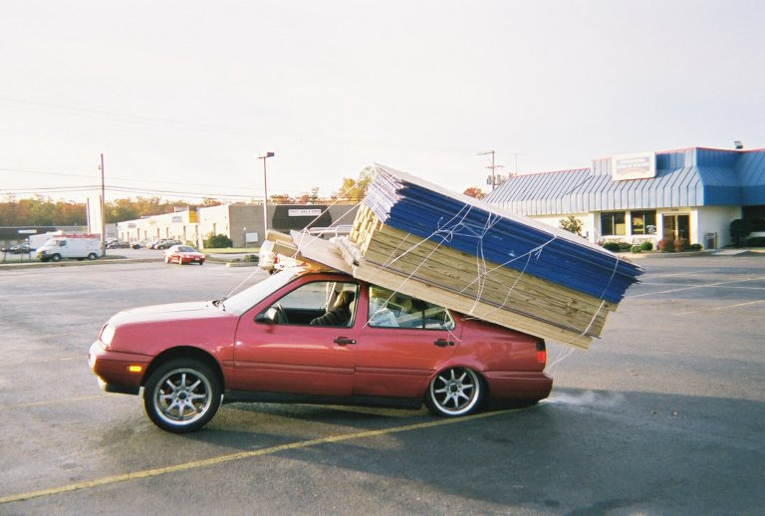
9. Pretty | 10. Ugly | 11. Intelligent | 12. Stupid
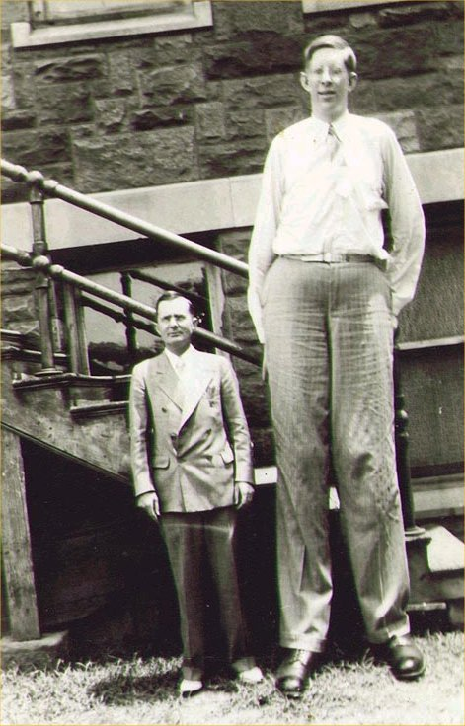 |  | 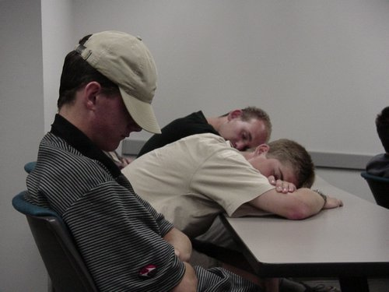 | 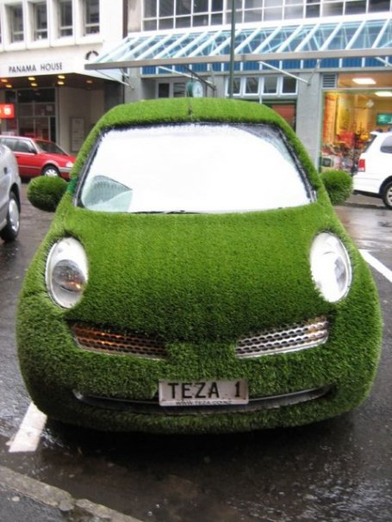
13. Tall | 14. Short | 15. Boring | 16. Interesting

 | The car is interesting.  It is an interesting car. | Is it interesting?  Yes, it is.
 | The boy is good.  He is a good boy. | Is he bad?  No, he isn’t.
 | The girl is pretty.  She is a pretty girl. | Is she ugly?  No, she isn't.
 | The man is short.  He is a short man. | Is he short?  Yes, he is.
 | The class is boring.  It is a boring class. | Is it interesting?  No, it isn’t.

