English Grammar: Equality/Inequality
We use the structure “as (adjective) as” to describe two equal things. For example:

- My wife is as beautiful as Selma Hayek.
- My son is as intelligent as Einstein.
- An Audi is as good as a BMW.
- My teacher is as strict as my father.
- My sister is not as clever as my brother.
- The Empire State Building is not as tall as the Burj Khalifa.

An English “simile” is an expression which equates two things, often in a funny way. Examples:
- as clear as mud “Thanks for the explanation. It was as clear as mud!”
- as cool as a cucumber “My brother is as cool as a cucumber. He’s great!”
- as deaf as a post “My grandmother is as deaf as a post.”

Exercise 1. Complete the following sentences using “as…as”:
1. John is (tall) _________________ Peter.
2. Janet is (beautiful) _________________ Jennifer.
3. You are (crazy) ____________________ my sister.
4. We can run (fast) ______________________ them.
5. My dad is (not / strict) _________________ your dad.
6. Your cell phone is (not / cool) ___________________ mine.
7. “Matrix 2” was (not / good) ___________________ “Matrix 1”.
8. This pie is (not / tasty) _______________ the one which I ate yesterday.

Exercise 2. Complete the following sentences using “as…as” or “not as…as”.
1. São Paulo is ___________________________ Rio.
2. Buses are ____________________________ cars.
3. Fortaleza is ____________________________ Recife.
4. Volleyball is ____________________________ basketball.

Exercise 3. Rewrite the following sentences using “as…as” or “not as…as”.
Examples: Recife is hot. Fortaleza is hot too.
Fortaleza is as hot as Recife.

Dana’s dog is bigger than Jamie’s dog.
Jamie’s dog is not as big as Dana’s dog.

1. Apples are healthier than ice cream.
_____________________________________________________________________
2. Ann’s cellphone is newer than my cellphone.
_____________________________________________________________________
3. Joe is 80 years old. Jeff is 80 years old too.
_____________________________________________________________________
4. China is bigger than Taiwan.
_____________________________________________________________________
5. Linda can run fast. Ryan can run the same speed.
_____________________________________________________________________


Exercise 4. Can you complete these English similes?
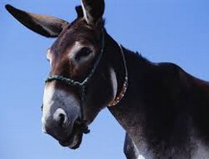
1. As strong as _____________.
2. As stubborn as _____________.
3. As useless as _____________.
4. As fast as _____________.
an ox
5. As cold as ____________.
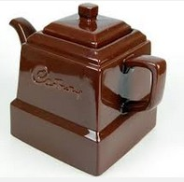
a mule



a chocolate teapot
ice
lightning

We can also use this structure for irony. For example:

- You are as useful as a chocolate teapot.
- His visit is as welcome as a fart in a spacesuit.

