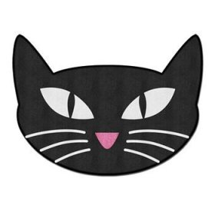
Superstitions
Are you superstitious? Do you believe in good and bad luck?
Exercise 1. Do these actions bring good or bad luck? Write G (good) or B (bad):
- A black cat walks across your path _______
- Walking on a crack in the pavement _______
- Putting a horseshoe above your door _______
- Finding a four-leaf clover _______
- Walking under a ladder _______
- Putting new shoes on a table _______
- Seeing three butterflies together _______
- Pulling out a loose eyelash _______
- Opening an umbrella indoors _______

Song suggestion: “Superstition”: https://www.youtube.com/watch?v=JL9eO4-aDMs (5 mins)

Exercise 2. Match the actions on the left with the consequences on the right:
1. If you break a mirror, | a) a visitor is coming.
2. If your ears are burning, | b) you will have good health in the winter.
3. If a bee enters your home, | c) you will have seven years of bad luck.
4. If you dream about a lizard, | d) you are going on a journey.
5. If your right foot itches, | e) you have a secret enemy.
6. If you catch a falling leaf on the first day of autumn, | f) you will never see him/her again.
7. If you say goodbye to a friend on a bridge, | g) someone is talking about you.
Answers (in white): 1-c 2-g 3-a 4-e 5-d 6-b 7-f

Exercise 3. (verbal) What do you know about these superstitions?

- Touch wood
- Friday the 13th
- A rabbit’s foot
- Throw salt over your left shoulder
- Whistle indoors
- Spilled salt

