English Grammar – “Allowed to” (rules)
Informal English: You can smoke here.
You can’t smoke here.
Formal English: You are allowed to smoke here.
You aren’t allowed to smoke here.
Other vocabulary:
to permit somebody to do something
It is permitted to smoke.
My wife never permits me to smoke.

to let somebody do something
He lets me smoke.
Please let me smoke.

to authorize somebody to do something
He is authorized to enter.
I can give you authorization to enter.

to disallow something / to disallow somebody to do something
Facebook disallows the use of fake news.
The law disallows companies from importing raw materials from abroad.

to ban something/ to ban somebody to do something
Facebook bans the use of fake news.
The law bans companies from importing raw materials from abroad.

to prohibit somebody from doing something
It is prohibited to smoke.
My wife prohibits me from smoking.

to forbid somebody to do something
It is forbidden to smoke.
My wife forbids me to smoke.

to bar somebody from somewhere / to bar somebody from doing something
He is barred from the bar.
The college bars everybody from taking drinks away.

Conversation
What are the rules at your office? What are you allowed to do? What are you not allowed to do? Are you allowed to smoke? Are you allowed to wear anything you like? Are you allowed to go home early? Are you allowed to arrive late?

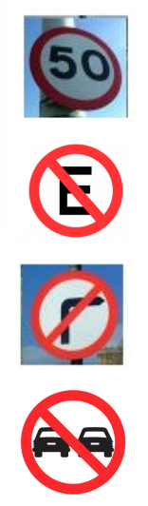
Exercise. Describe the rules below.

You are allowed to drive up to 50 kph (or mph).
or: You aren’t allowed to drive over 50 kph (or mph).

(Note: ‘P’ in the UK or USA)
______________________________________________

______________________________________________

______________________________________________


_______________________________________________




