English Grammar – the Apostrophe

1) Missing letter(s):
I’m English. (I am)
He’s very happy. (He is)
He’s two cars. / He’s got two cars. (He has)
What’s he like? (What is)
What’s he like? (What does)
I’d visited Paris twice before. (I had)
I’d like to go now. (I would)
We’re studying French. (We are)
They’ve been here before. (They have)
What’s your name? (What is)
It’s six o’clock. (It is six of the clock.)
He isn’t ready. (is not)
We aren’t listening. (are not)
I don’t like coffee. (do not)
He doesn’t come here often. (does not)
We haven’t brought our books. (have not)
Let’s go! (Let us go!)
Sean O’Brien (Sean of Brien)
Rock ‘n’ Roll (Rock and Roll)

2) Possession:
Example: John’s book = the book of John

a) Things:
This is John’s book. / The book is John’s.
This is Cristina’s notepad. / The notepad is Cristina’s.
I like Michael’s computer. / I like computers, especially Michael’s.
Mr. Brown’s class is very big.
Curitiba’s mayor lives in a big house.
England’s population is growing.
The United States’ population is growing.
The teacher’s room. (1 teacher, 1 room)
The teachers’ room. (Many teachers, 1 room)
The teachers’ rooms. (Many teachers, many rooms)

b) People:
His uncle’s friend.
Peter’s mother.
Our daughter’s boyfriend.
My mother’s second husband.
Lucas’ wife.
We're going to spend Christmas at John’s girlfriend's parents' house.

Note: When we put an apostrophe after an ‘s’ (for example a name or a plural), we don’t use another ‘s’ after the apostrophe.

Video suggestion: Its vs It’s
https://www.merriam-webster.com/video/its-vs-its

Exercise 1. Translate to English, using at least one apostrophe:

1. Sou brasileiro.
__________________________________________________________________________

2. Eu gostaria de um taça de vinho.
__________________________________________________________________________

3. Eles têm três cachorros.
__________________________________________________________________________

4. Nós não estamos felizes.
__________________________________________________________________________

5. São dez horas.
__________________________________________________________________________

6. Onde está a caneta da Suzy?
__________________________________________________________________________

7. Eu estou na sala de professores.
__________________________________________________________________________

8. Quem é o pai do Pedro?
__________________________________________________________________________

9. Eu adoro os filhos dos Browns.
__________________________________________________________________________

10. A população do Canadá é de 35 milhões.
__________________________________________________________________________

11. Eu sou o marido da Mary.
__________________________________________________________________________

12. Eu gosto de “Rock e Roll”.
__________________________________________________________________________

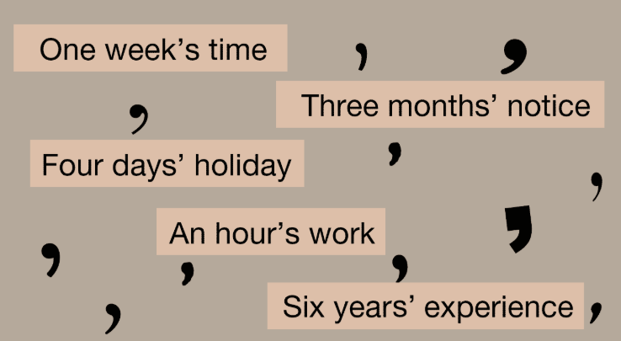
Exercise 2. Select the correct option:

1. The dog ate _______________ (it's, its) dinner.

2. I think that _______________ (it's, its) going to rain tomorrow.

3. The team elected _______________ (it's, its) captain yesterday.

4. The man said that _______________ (it's, its) too hot to play baseball.

5. _______________ (You're, Your) studying apostrophes in this lesson.

6. _______________ (You're, Your) book is on the table.

7. If _______________ (you're, your) ready, you may begin the test.

8. Please give me _______________ (you're, your) opinion.

9. Tom said that _______________ (he's, his) lost his iPad.

10. Jerry will lend you _______________ (he's, his) book tomorrow.

11. _______________ (Their, There, They're) going to win the game!

12. _______________ (Their, There, They're) children are really nice.

13. _______________ (Their, There, They're) are many cars in São Paulo!

14. John and Jill borrowed my car. _______________ (Their, There, They're) car is in the workshop.

15. It was Mr. Lee _______________ (whose, who's) car was stolen.

16. _______________ (Whose, Who's) going to the soccer game?

17. _______________ (Whose, Who's) is this book?

18. Karen was the teacher _______________ (whose, who's) book was chosen to be published.

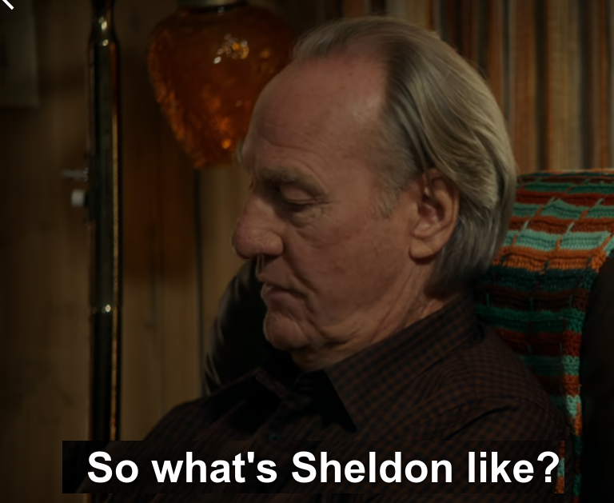
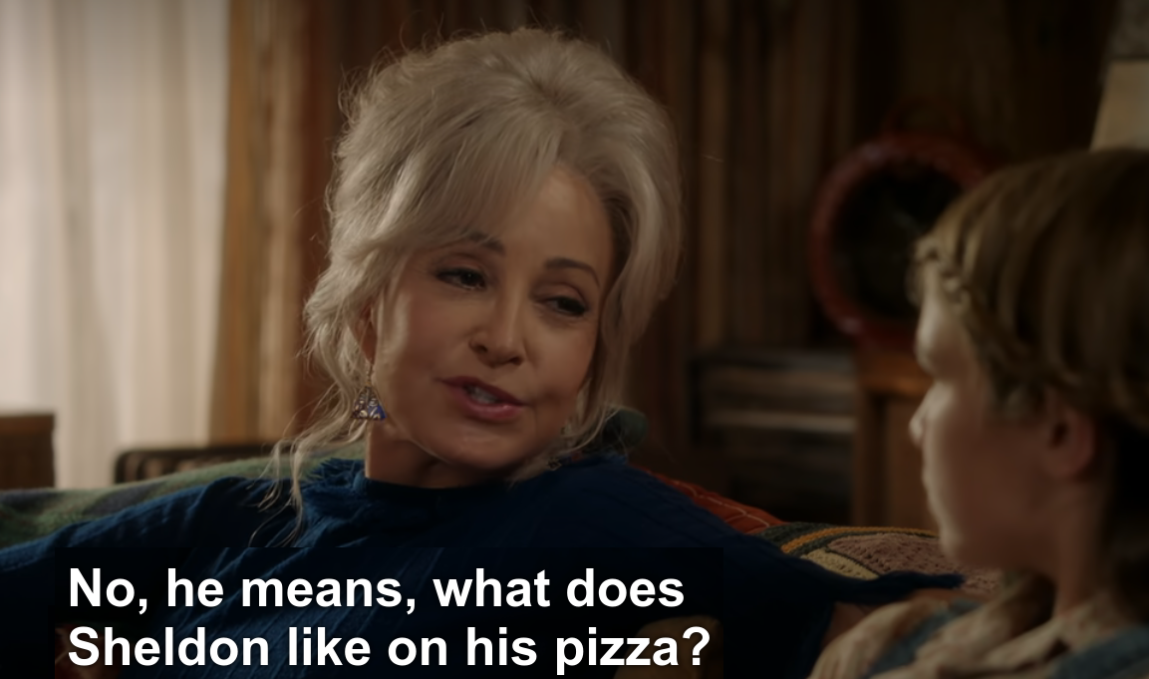
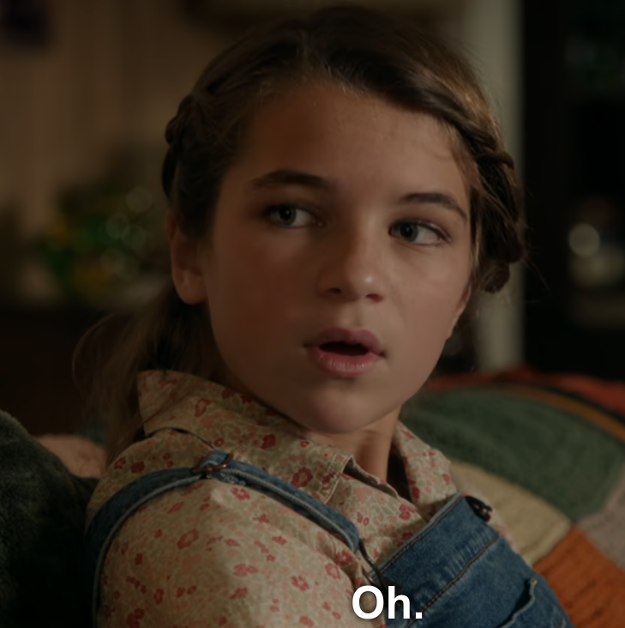
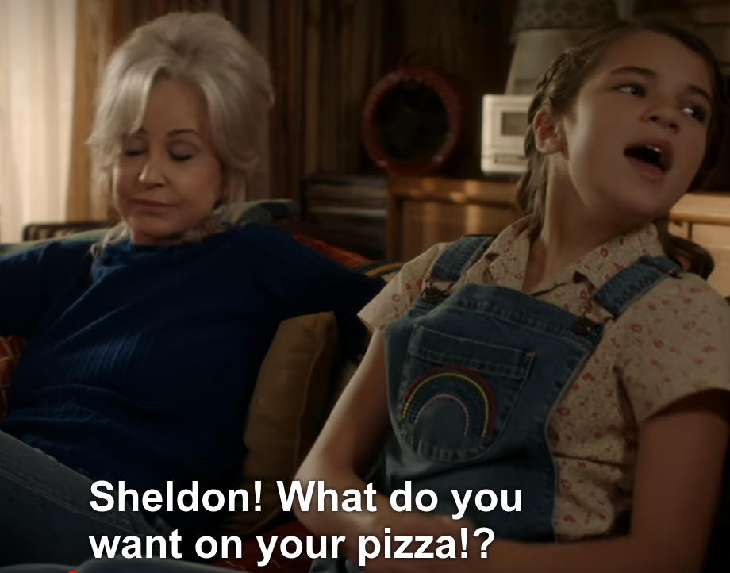
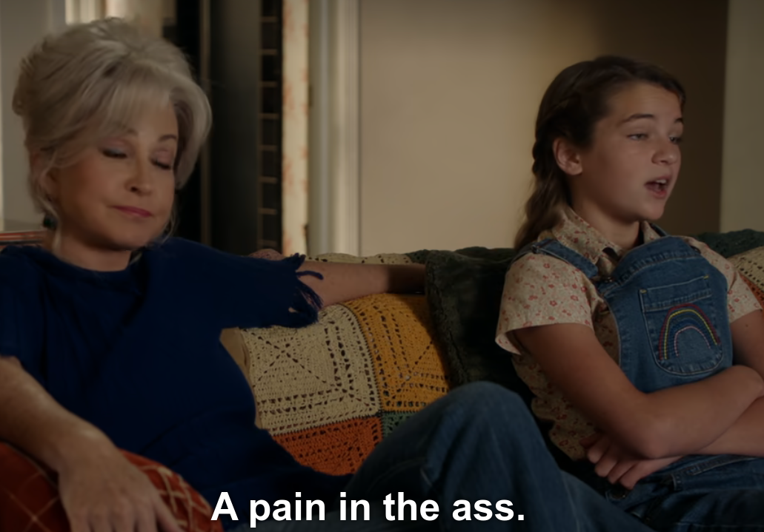
Ordering Pizza - “What’s he like?” (‘does’ vs ‘is’)

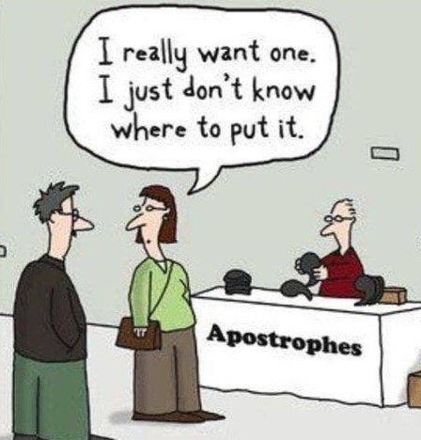
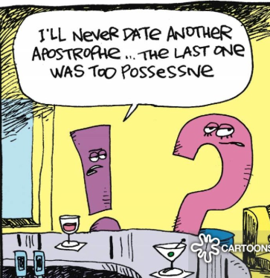
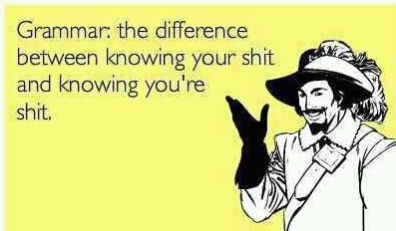
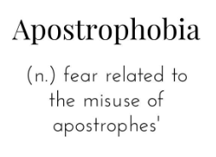
Here are some jokes about the apostrophe:
