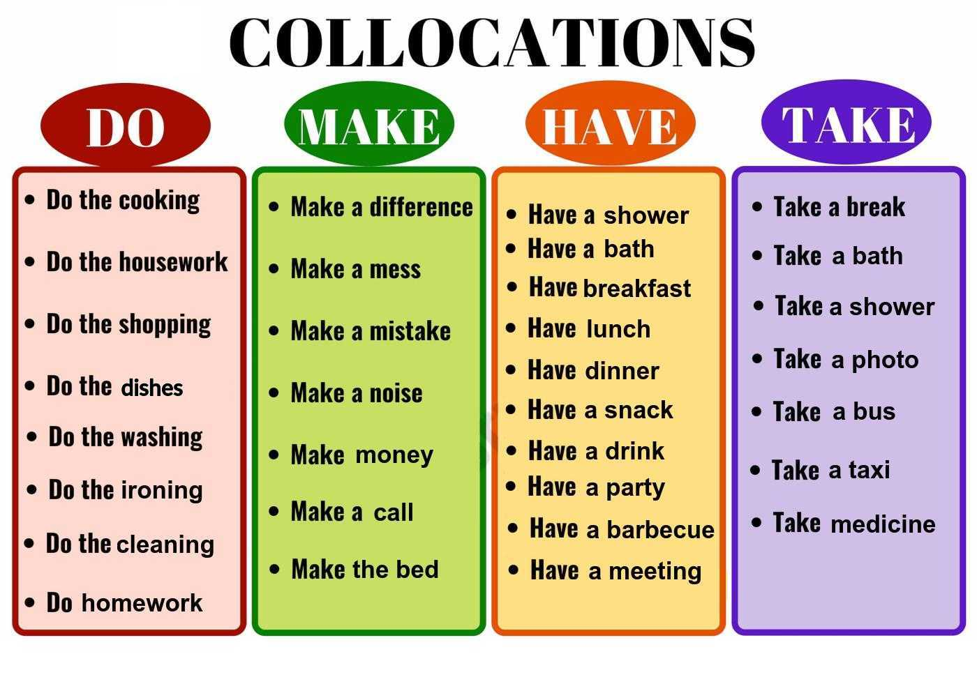

In the exercise on the next page, there is sometimes more than one possible answer. If you don't know the answer, look for it online.

