English Grammar - The Subjunctive Mood

The Subjunctive form (or “mood”) is used for an action which is desired or recommended. It is used with certain verbs and expressions and always uses the bare infinitive form of the verb. The complete structure is:

Desire/Recommendation + “that” + subject + bare infinitive + ....

For example:

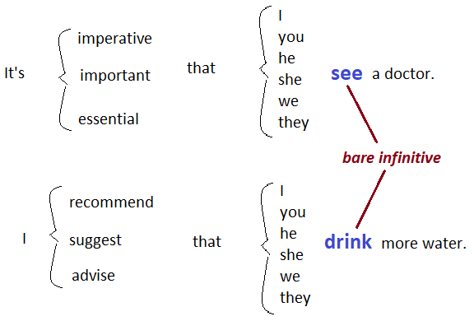

Here are some verbs and expressions which can use the Subjunctive form:
- to advise  - to ask  - to demand  - to desire  - to insist  - to propose  - to recommend  - to request  - to suggest  - to urge | - It is best that ......  - It is crucial that ......  - It is desirable that ......  - It is essential that ......  - It is imperative that ......  - It is important that ......  - It is recommended that ......  - It is urgent that ......  - It is vital that ......  - It is obligatory that ......

Examples:

- I suggest that he go to the meeting.
- The doctor recommended that I have an operation.
- It is essential that we be there.
- It is important that he take the medicine.
- The committee requested that Peter submit his proposal by the end of the week.
- We insist that all the trainees be on time.
- The company desires that Mr. Jones attend all financial meetings.
- It is obligatory that he get an X-ray.

It is not easy to notice the Subjunctive form when we use 'I/you/we/they', but it is easy to notice when we use 'he/she/it'.
For example:

- I recommend that you go to the meeting.
- I recommend that he go to the meeting.

- He tries to study hard.
- It is important that he try to study hard.

The Subjunctive form can also be used in the negative, passive and continuous forms.

Examples:

- Negative: The company asked that their employees not accept personal calls at work. (we do NOT use an auxiliary verb)

- Passive: It was recommended that she be hired for the position. (be + past participle)

- Continuous: It is important that a car be waiting when the delegates arrive. (be + present participle)

And God said: “Let there be light.”

Source: https://www.ecenglish.com/learnenglish/lessons/subjunctive-0

More reading: https://www.englishclub.com/grammar/subjunctive.htm
Exercise

1. It is important that he _______________ to reply immediately.
- will remember
- remembers
- remember

2. I suggest that Peter _______________ to the customers’ complaints himself.
- listen
- can listen
- listens

3. He demanded that the problem _______________ addressed immediately.
- is
- be
- to be

4. It is recommended that you _______________ at the court for the sentence.
- are waiting
- will wait
- be waiting

5. The professor insisted that we _______________ our research within a month.
- submit
- submitted
- would submit

6. It is a very good idea that he _______________ in the USA for one year.
- studies
- be studied
- study

7. Due to the bad weather it is advised that the ship _______________ sail.
- would not set
- did not set
- not set

8. It is imperative that all non-essential employees _______________ immediately.
- let go
- be let go
- be letting go

