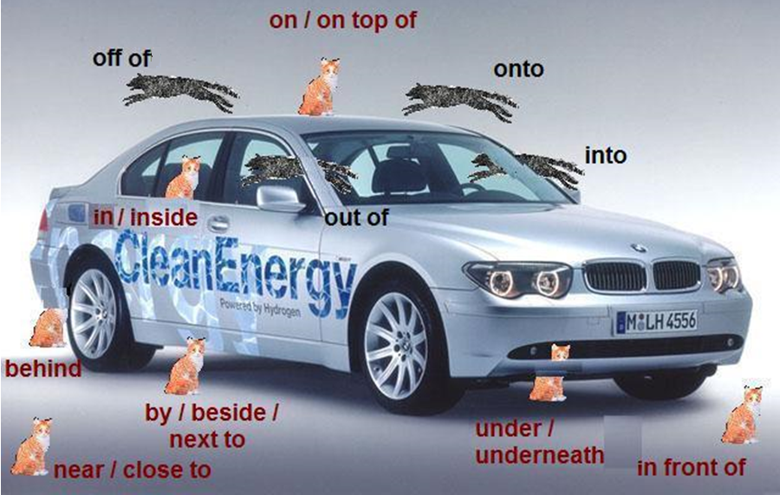
English Prepositions – Location and Movement

Examples: The cat is inside the car.
The cat jumped into the car.
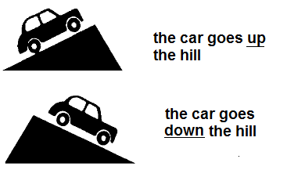
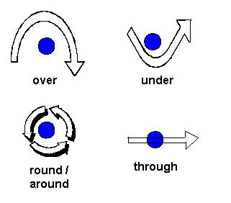
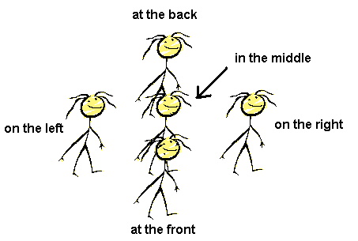
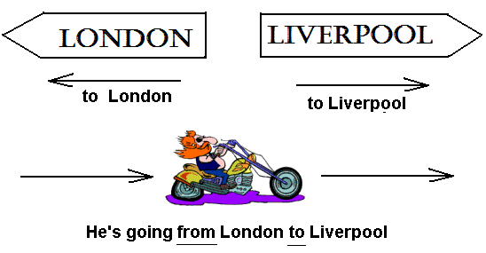
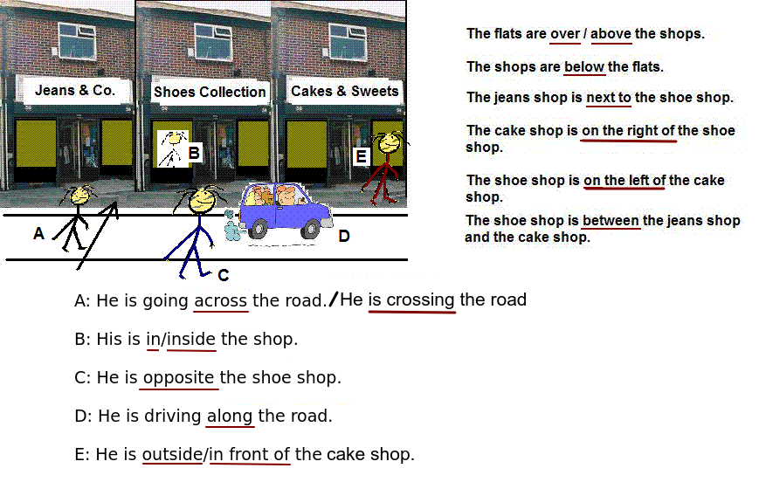
Locations:

at home
at work
at school/college/university
at the office
at the bank/museum/post office/station
at the airport
at the table/desk

at the hospital (you are visiting) / in the hospital (you are sick)

on the corner (of) ...
in the street/road
on the left/right

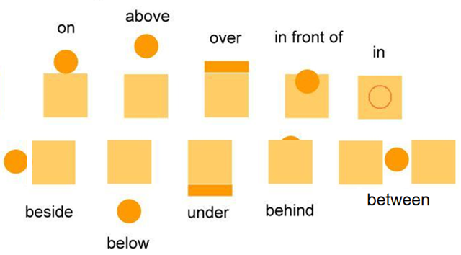



among

