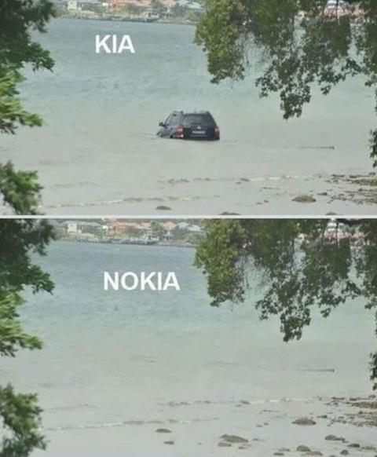
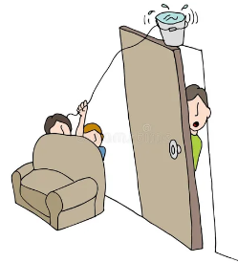
Language & Communication
According to various studies around the world, communication has many facets and can be summarized as follows:
1) The words – only 7% !!!
The words that we actually say mean very little. What’s much more relevant is how we say them!

2) Word quality – 38%
The way we say our words carries a lot of information, specifically:
- Intonation
- Pronunciation
- Volume
- Pitch
- Speed
Here are some examples of phrases. If they are spoken with different intonations, volumes, pitches and speeds, they deliver different meanings.
A) “Do you want some of this?”



Spoken with aggression

Spoken with kindness
B) “Ha ha ha. So funny.”

Spoken with joviality Spoken with anger / irony / sarcasm
3) Body language – 55%
Surprisingly, it’s our body language which communicates the most information, specifically:
- Hand gestures
- Facial expressions
- Posture
- Clothes


