Endonyms and Exonyms

Definitions: Endonym: The name of a country or city used by its inhabitants

Exonym: The name of a country or city used by another country

Some people say that we shouldn’t change or translate the names of places. However, sometimes the name of a place, as spoken by its inhabitants, is very difficult to pronounce by foreigners. So they often change the name in a way that is easier to pronounce. However, sometimes an exonym is totally different from the endonym. Here are some examples:

Endonym | Exonym (English) | Exonym (Portuguese)
Brasil | Brazil | ------
Россия (Russia) | Russia | Rússia
France | France | França
Australia | Australia | Austrália
España | Spain | Espanha
England | ------ | Inglaterra
London | ------ | Londres
Scotland | Scotland | Escócia
Cymru | Wales | País de Gales
Lisboa | Lisbon | ------
Köln | Cologne | Colônia
Ελλάδα (Ellada) | Greece | Grécia
日本 (Nihon) | Japan | Japão
Suomi | Finland | Finlândia
Nederland | The Netherlands | Países Baixos
ประเทศไทย (Prathethy) | Thailand | Tailândia
中国 (Zhōngguó) | China | China
Türkiye | Turkey | Turquia
Deutschland | Germany | Alemanha

Suggested video: https://www.youtube.com/shorts/lSvM43eLh2k (1 minute)

Türkiye

In 2021, the Turkish government requested that all countries write the name of their country as the natives do. In June 2022, the United Nations agreed to recognize the new spelling, and in January 2023, the USA agreed to do the same.
See: https://www.npr.org/2023/01/08/1147704945/the-state-department-will-begin-spelling-turkey-as-turkiye

Deutschland
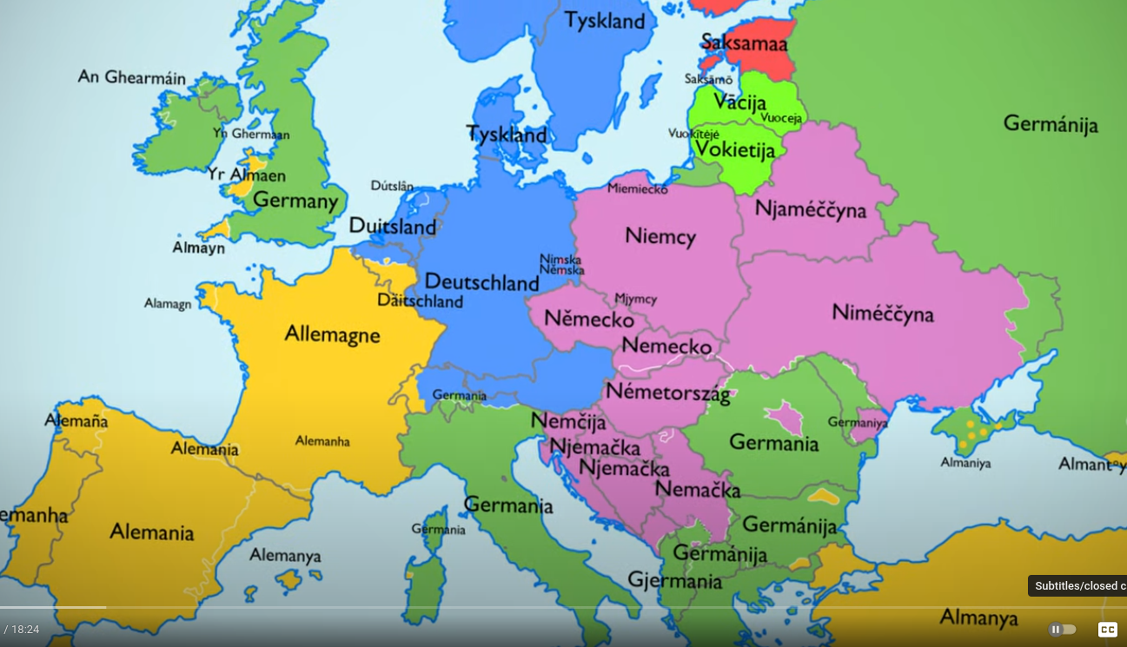

The word “Deutschland” means “Land of the People”. There are six variations of exonyms for this country (see the colours on the map above). Let’s examine their origins and meanings:
1. Tyskland, Duitsland – these words also mean “Land of the People”. “Tyskland” is used in Denmark, Sweden and Norway, and “Duitsland” in The Netherlands (blue regions).
2. Germany – from the Latin word “Germania” which means “Land of the Germani”. The origin of the word “Germani” is unknown, but it could be from Anglo-Saxon meaning “neighbours”. Many countries use variations of the word “Germania” (green regions).
3. Alemania – derived from the name “Alamanni” which was the name of a tribe who lived in what is Southern Germany today. Many countries use variations of this word (yellow regions).
4. Niemcy – from the Slavic language meaning “The Silent Ones”. About 12 countries use variations of this word (purple regions).
5. Saksa – derived from the word “Saxon”, the name of the people who lived in what is Northern Germany today. Only two countries use variations of this word; Estonia and Finland (red regions).
6. Vacija – the origin of this word is unknown, but it could be from Indo-European meaning “war cry”. Only two countries use variations of this word; Latvia and Lithuania (bright green regions).
Source: https://www.youtube.com/watch?v=acT46W6EGPs (18 mins)

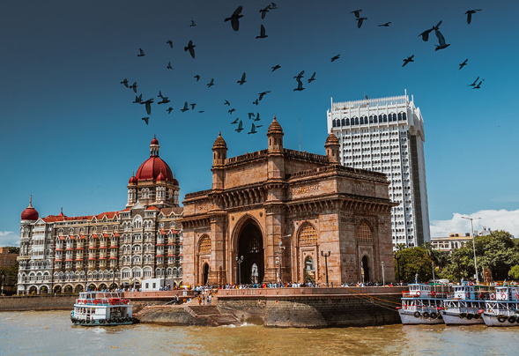
Bombay vs Mumbai
The city’s earliest recorded names were Kakamuchee and Galajunkja. However, the city was referred to as Manbai in historical texts in 1507. In Lendas da Índia, written in old Portuguese by Gaspar Correia, the city was referred to as Bombaim, meaning ‘good bay’. ‘Bombay’ is an anglicized version of this name, used by the British when they took control of the city in the 17th century. Historical records show that the city was also referred to as Mombayn, Bombain, Bombaym, Monbaym, Mombaim, Mombaym, Bambaye, Bombaiim, Bombeye, Boon Bay, and Bon Bahia at different times in its history!
The name ‘Mumbai’ was derived from the name of the Koli goddess Mumbadevi, who is the city’s patron deity. And so many Kannada speakers called the city Mumbai even though it was Bambai to Hindi speakers and Bombay in official British records.
The city’s official name change, from Bombay to Mumbai, happened when the political party Shiv Sena came to power in 1995. The party regarded the name Bombay as a legacy of British colonialism, and wanted the city’s name to reflect its true heritage, renaming it to pay tribute to the goddess Mumbadevi.
This name change is part of a larger, ongoing process in which places across India have undergone name changes to remove the British names.

