Homo vs Hetero

Latin: “homo” = ”same” “hetero” = “different”
“phone” = “sound” “graph” = “written” “nym” = “name”
“syn” = “together” “anti” = “opposite”

Homophone: Words that have the same sound or pronunciation,
but have different meanings (also: “heterograph”)
Examples: to / two / too

Homograph: Words that have the same written form,
but have different meanings (also: “heterophone”)
Examples: perfect (adjective) / perfect (verb)
read (present tense) / read (past tense)

Homonym: Words that have the same sound and written form,
but have different meanings.
Examples: right (correct) / right (opp. of left)
mean (adjective) / mean (verb)

Synonym: Words which have the same meaning.
Examples: speed / velocity, film / movie

Antonym: Words which have opposite meanings.
Examples: right / wrong, up / down

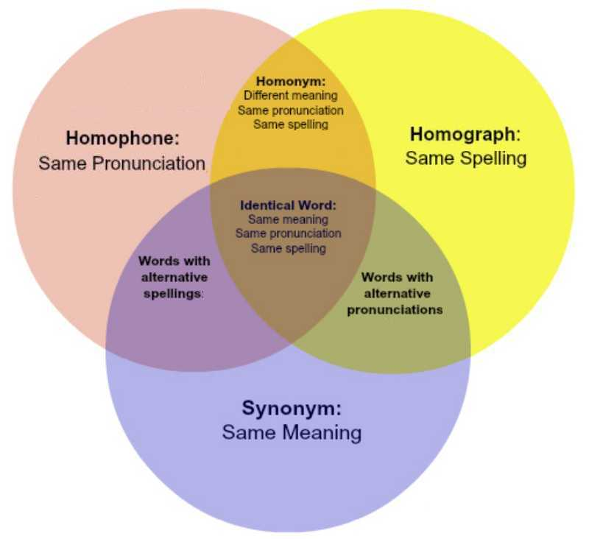

Words with alternative spellings: color / colour, gray / grey
Words with alternative pronunciations: fragile, herb, address
Words with alternative spellings and pronunciations: aluminum / aluminium

