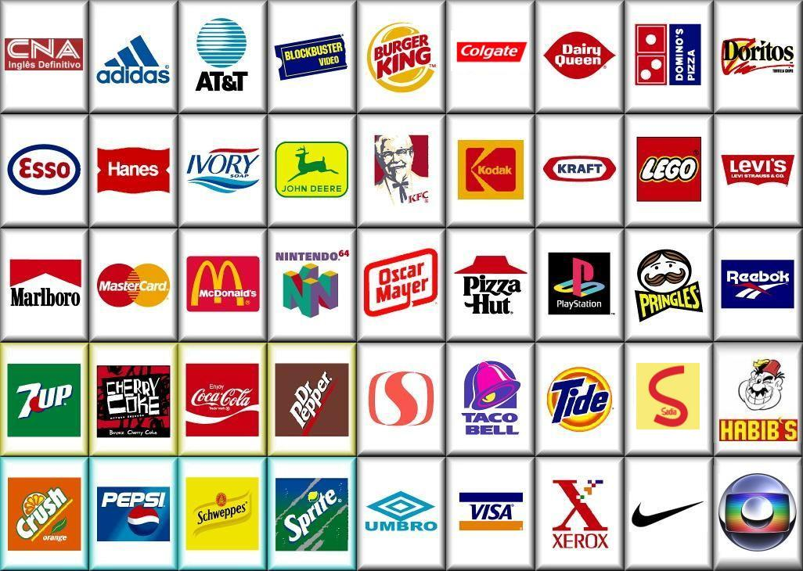
Brand Names & Logos

- Which of these logos do you recognize?
- Do you buy any products from these companies?
- Which of these companies have you never heard about?

Pronunciation:
Nike: https://www.youtube.com/shorts/OcwHXkHRMus (short)
Adidas: https://www.youtube.com/shorts/mg_vuna_J_w (short)
Levi’s: https://www.youtube.com/shorts/JdAbtMuKDo0 (short)

