MALEFIZ

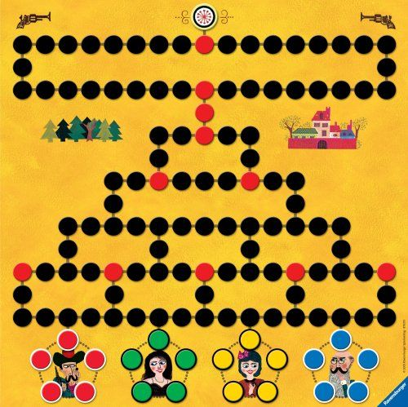
This is a competitive board game, which encourages selfishness, ambition, cruelty and generally malicious behavior. Helping a ‘friend’ during the game is not recommended, since it simply diminishes your own chances to win and doesn’t necessarily help your ‘friend’ to gain a significant advantage. Also, there is no guarantee that your ‘friend’ will help you in return.

If you are “in the lead”, the other players will probably try to slow you down by making your progress difficult.

It is similar to a running race – you only need to think about yourself and the only goal is to win! But, in this game, you can make your opponents progress very difficult!

How to Play

The winner is the first player to reach the top of the board. Using the die, you progress up the board, throwing again if you throw a ‘1’.

You can pass over another player, but you send him/her to home if you land on him/her. You cannot pass over a castle, but you can reappoint it if you land on it.

Game Vocabulary

Whose turn is it?
It’s my turn.
It’s your turn.
It’s John’s turn.
Throw again.
What did you throw?
Gotcha! (I got you)
Sorry! (SQN!)
John is in the lead. Let’s slow him down!
That’s mean!
You’re mean!
I’m gonna win!
You’re so lucky!
I’m so unlucky!
I need a ‘1’.
I never throw a ‘1’.
I’m gonna get you!
Send him/her home!

