
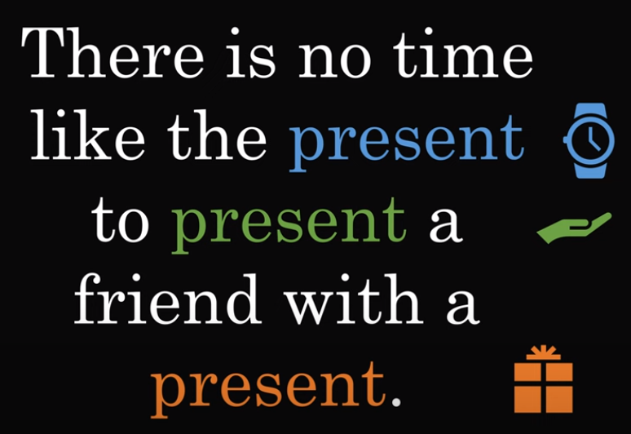
Homographs - One written word, two different pronunciations
(from Latin: “homo”=”same”, “graph”=“written”)

Sometimes in English, one written word can have two meanings and different pronunciations. These words are called “homographs”. Sometimes the meanings are similar, but sometimes they are completely different. Here are some examples:

1a. John lives in California. 1b. Doctors save many lives.
2a. I read the news every day. 2b. Have you read the news today?
3a. The Sahara desert is enormous. 3b. I will never desert you.
4a. I received a birthday present. 4b. I would like to present my wife, Alice.
5a. He can lead people very well. 5b. I think that the metal lead is very heavy.
6a. He always does his homework. 6b. The bucks are chasing the does.
7a. The wind is very strong today. 7b. Please wind the bandage around his leg.
8a. I must polish the table. 8b. I have a Polish table.
9a. Your English is almost perfect. 9b. I need to perfect my English.
10a. The streets are full of refuse. 10b. I refuse to cooperate.

For nouns or adjectives, the first syllable is stressed, but for verbs, the second syllable.

Noun Verb
protest to protest
record to record
suspect to suspect
import to import
contract to contract
conflict to conflict

Exercise 1. Say the following words, firstly as a verb and secondly as a noun or adjective:

insult | desert | increase | subject
reject | present | progress | produce
convict | object | refuse | perfect

Exercise 2. Read these sentences:

The lawyer did not object to the new object.
I had to subject each subject to a series of tests.
The dump was so full that it had to refuse more refuse.
The soldier decided to desert when he was in the desert.
This is a good time to present a birthday present to my wife.
The farm used to produce many different kinds of produce.
Exercise 3. Read these sentences:

I need to perfect my almost perfect English.

My doctor is fantastic! He lives to save lives!

He can lead people very well and he uses lead bullets.

He released a white dove into the air. (Note: “dove” rhymes with “love”)
The bird dove into the sea.

The nurse wound the bandage around the wound.

My neighbors always row late at night.
I always sit in the back row of the cinema.

The buck does strange things when the does are around.

The wind was so strong, that he couldn’t wind the sail.

The Polish maid must always polish the furniture. (Note: the verb “to polish” breaks the rule of “Verbs have stress on the second syllable”.)

I caught a sea bass yesterday.
John plays the lead guitar and Martin plays the bass guitar.

Just a minute please.
Here are the minutes of the meeting.
My cell phone chip is minute.

The insurance was invalid because he was an invalid.

As you are close to the door, can you please close it?

When I tear my shirt, I cry a tear.

How can I intimate this to my most intimate friend?

Please take a bow, then you can tie a bow in your shoelace.

Are you content with the content of the report?

Russia has more than one defect, which is why many Russians defect.

Suggested videos: https://www.youtube.com/shorts/ATPtszTO6mc (short)
https://www.youtube.com/watch?v=ozqluN8Eg0s (15 mins)
https://www.youtube.com/watch?v=N1VYBbsKgmE (15 mins)

Notes: The verbs “find/found” and “wind/wound” have similar pronunciations.
The verbs “wear/wore/worn” and “tear/tore/torn” have similar pronunciations.

Homographs don’t exist in Portuguese, because there are accents to help with pronunciation. For example: sabia / sábia / sabiá

