English Pronunciation – “live”

1) to live (verb) (short vowel sound) (PT: morar/viver)

Morar: Viver:
I live in London. She lives dangerously!
He lives in Liverpool. We live for fun!
They live in a big house. I love to live!
Where do you live? Do you work to live or live to work?
I like to live in Brazil. You need to learn how to live well.
Do you live abroad? He lives very well.
She wants to live in Canada. It’s difficult to live like this.

2) live (adjective) (long vowel sound) (PT: ao vivo / energizado)

I prefer to listen to live music. Be careful – these wires are live.
Pink Floyd will play their best songs live in Berlin. Susan is a real live wire!
This is a live camera.

3) life/lives (noun) (long vowel sounds) (PT: vida/vidas)

The doctor saved a life today. Doctors save many lives every day.
When you lose three lives, you have to start the game again.
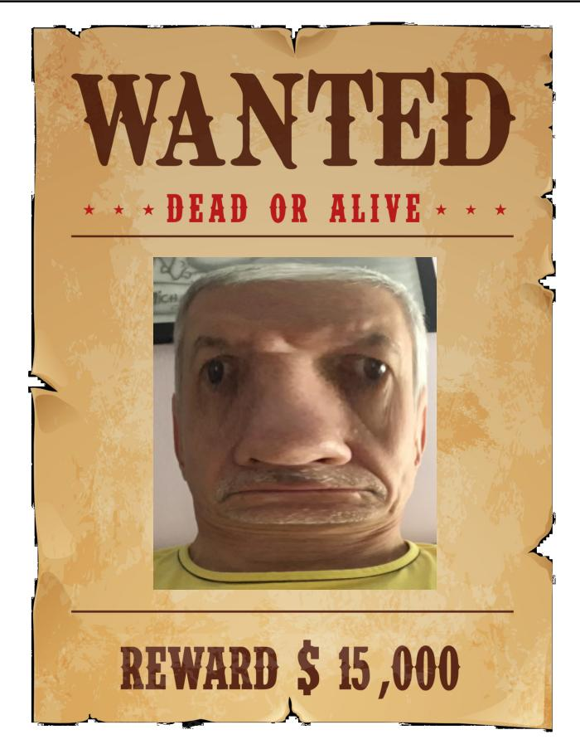
Cats have nine lives.

4) alive (adjective) (long vowel sound) (PT: vivo(a))

I don’t know if he is dead or alive.
On a far-west poster: “Wanted – Dead or Alive”
He is in a critical condition, but at least he is alive.
This is a dead cat and this is an alive cat.

5) lively (adjective) (long vowel sound) (PT: vivaz/animado(a))

His parties are always lively.

6) livelihood (noun) (long vowel sound) (PT: meios de subsistência)

John believes that the new regulations threaten his livelihood.

Exercise. Read these sentences:
1. They live in a good neighborhood.
2. His life is dedicated to saving lives.
3. He doesn’t know how to live well!
4. In 1980, I had the opportunity to see Pink Floyd play live.
5. The boy was lucky to be alive after 5 days alone in the jungle.
6. When the airplane crashed, 68 lives were lost.
7. I live for live music.
8. Our wedding was a lively event.

