English Pronunciation: ‘ough’

In English, the combination of letters 'ough' can be pronounced in nine different ways:

1. ‘o' as in 'go' Example: though
2. schwa as in ‘the’ Example: thorough ¹
3. 'or' as in 'sort' Example: brought
4. 'off' as in 'coffee' Example: cough
5. 'ow' as in 'cow' Example: plough ²
6. 'uff' as in 'cuff' Example: enough
7. 'up' as in 'cup' Example: hiccough ³
8. 'oo' as in 'boot' Example: through ⁴
9. 'ock' as in 'sock' Example: lough ⁵

1 – schwa (British English) / 'o' as in 'go' (American English)
2 – plough (British English) / plow (American English)
3 – hiccough (British English) / hiccup (American English)
4 – can be written as thru’ in American English
5 – Synonyms: lake, loch, lagoon

Exercise 1.
Listen to your teacher pronounce the following words and repeat them. They are in groups of similar pronunciation.

1) -off  past forms of verbs:  buy, bring, fight, think | cough | trough
2) -ort | bought | brought | fought | thought
3) -uff | enough | rough | tough
4) -ow | bough | plough | drought
5) -o | though | although | dough
6) -oo | through

Exercise 2.
Some names of cities, towns and districts also use the combination of letters 'ough'. Listen to your teacher say these names and repeat them:

Slough, Loughborough, Peterborough, Loughton.

Exercise 3. Practise saying these sentences:
1. I have a lot of work to do, though I'm tired.
2. When the going gets tough, the tough get going.
3. Although I am tired, I must continue working.
4. I live near the park, so every day I walk through the park to go to work.
5. Well, Bob. You have done a thorough job with this report – excellent!
6. I have always tried to do my best throughout my life.
7. I thought he was thoroughly wrong!
8. The tough cow eats enough from the trough with its rough tongue.
9. English is difficult, but it can be learned through tough thorough thought, though!
10. Although I coughed roughly and hiccoughed throughout the lecture, I thought that I could plough through it until the end.
11. Don’t hiccough though, a rough cough is thorough enough.

Exercise 4. Complete the sentences using the given words (use each word once only). Refer to Annex 1 if necessary.

thorough though thought through throughout trough

1. I ____________ that you said that you wanted to study French.
2. I have travelled around the world ____________ my life.
3. He is an extremely ____________ person. Always perfect details!
4. I will promote her, ____________ she will have to prove her worth!
5. You need to go ____________ the shop to get to the parking area.
6. The world's economy is a series of peaks and ____________s.

Exercise 5. The following list are important words to know. Listen to the teacher say these words, then repeat them:

1 | although
2 | bought (past of ‘buy’)
3 | brought (past of ‘bring’)
4 | cough
5 | enough
6 | though
7 | thought (past of ‘think’)
8 | through

Exercise 6. Repeat this poem after the teacher:

I take it you already know
Of ‘cough’, ‘enough’, ‘although’ and ‘though’?
Others may hesitate, but not you
On ‘bought’, ‘brought’, ‘thought’, and ‘through’?

Exercise 7. Discover the words.





1. _________________ 2. ________________ 3. ________________





4. _________________ 5. ________________ 6. ________________

Suggested videos: https://www.youtube.com/shorts/Uqj5L1NreVI (1 min)
https://www.youtube.com/watch?v=XXamk4NHNz0 (12 mins)
https://www.youtube.com/watch?v=iACq0AM_Mx8 (13 mins)
Annex 1. Translations.

although embora (no início da frase)
borough bairro
bough galho
bought comprei/comprou/etc.
brought trouxe/trouxemos/etc.
cough tossir/tosse
dough massa/dinheiro (informal)
drought seca
enough suficiente
fought lutei/lutou/etc.
hiccough soluço
lough lago
plough arado
rough áspero/violento/rascunho/difícil
thorough minucioso/meticuloso
though embora
thought pensei/pensou/etc.
through através
throughout ao longo de
tough duro/difícil
trough cocho/baixa *

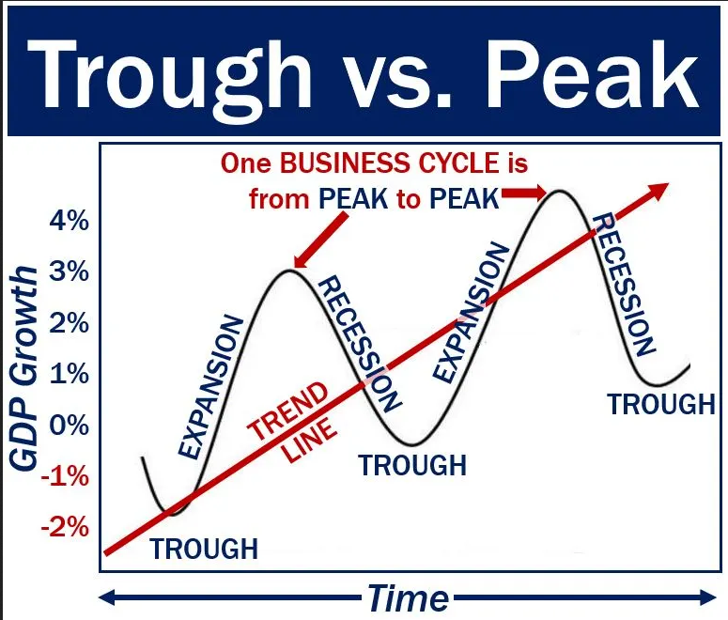
* peaks and troughs = altas e baixas

