Pronunciation: English Sounds
Vowel sounds (20) | Consonant sounds (24)
but, luck  part, father  cat, black  men, bed  America, teacher  word, learn  sit, thick  see, heat  my, five  not, rock  go, home  sort, daughter  tour, sure  book, put  too, blue  how, out  wear, air  day, eight  here, near,  boy, join | bed, lab  do, hand  five, if  go, leg  hello, how  yes, yellow  kilo, cat  live, little  milk, lemon  no, ten  sing, long  pig, map  read, try  six, miss  short, cash  church, chips  time, letter  think, both  the, mother  very, five  window, white  zoo, lazy  casual, vision  judge, large

The International Phonetic Alphabet

The above list of sounds has been formalized into the “International Phonetic Alphabet” (IPA). It is a phonetic notation system based on the Latin alphabet. It was created by the International Phonetic Association in 1888 as a standardized representation of the sounds of spoken English. The IPA is used by lexicographers, foreign language students and teachers, linguists, speech-language pathologists, singers, actors and translators.

Vowel sounds (20):
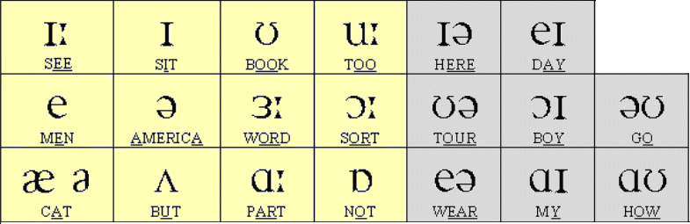

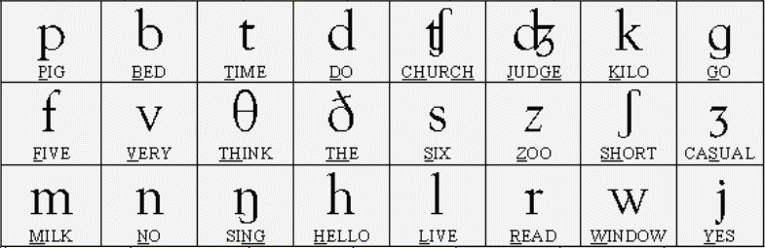
Consonant sounds (24):

When using the IPA to assist pronunciation, we use the symbol [ˈ] to indicate that the subsequent syllable is the tonic syllable (main stress), and the symbol [ˌ] to indicate that the subsequent syllable is the sub-tonic syllable. English words have only one or two tonic (stressed) syllables. For example:

“available” --> əˈveɪləbl
“unavailable” --> ˌʌnəˈveɪləbl

Phrases for vowel pronunciation practise:
- ɪː The bee sees me make tea for Dee.
- ɪ Dick sits on the bin in the kitchen.
- ʊ Look – he took the book from the rook!
- uː You two got the flu, too.
- ɪə I fear there is no beer here.
- eɪ The rain in Spain falls mainly on the plain.
- e Fred said that Ted is on the bed.
- ə Rodger is a teacher in America.
- 3ː I heard that I must learn the third turn.
- ɔː You ought to sort the four laws of the court.
- ʊə Are you sure the tour is pure?
- ɔɪ Oi! Your toy annoys the boy from Troy.
- ʊə Tony goes home slowly on a pony.
- æ The cat sat on the mat.
- ʌ For fun, place the butter under the cup.
- ɑː Art in the heart is far from the stars.
- z Tom is hot - he can not stop the cops.
- eə Clair is fair and she wears flares on the stairs.
- ɑɪ My flight is five in the night – I’ll try not to cry during the flight.
- ɑʊ How are you now, brown cow?

Phonetic Exercise. Write the English words:

ˈsɪərɪəs ________________________
ˈkeəfʊl ________________________
kənˈfjuːzd ________________________
ˈdʒenərəs ________________________
dɪˈtɜːmɪnd ________________________
streɪndʒ ________________________
breɪv ________________________
ˈdʒentl̩ ________________________
ˈɒnɪst ________________________
ˈkjʊərɪəs ________________________
flɔː ________________________
ˈbɑːθruːm ________________________
ˈkɪtʃɪn ________________________
ˈselə ________________________
ˌʌpˈset ________________________
ˈmʌʃrʊm ________________________
biːn ________________________
ˈkæbɪdʒ ________________________
pəˈteɪtəʊ ________________________
ˌθɜːˈtiːn ________________________
nəʊz _______________________
ˈʃəʊldə ________________________

Source: https://www.englisch-hilfen.de/en/exercises_list/aussprache.htm

