English Grammar: Phrasal Verbs with “ask”
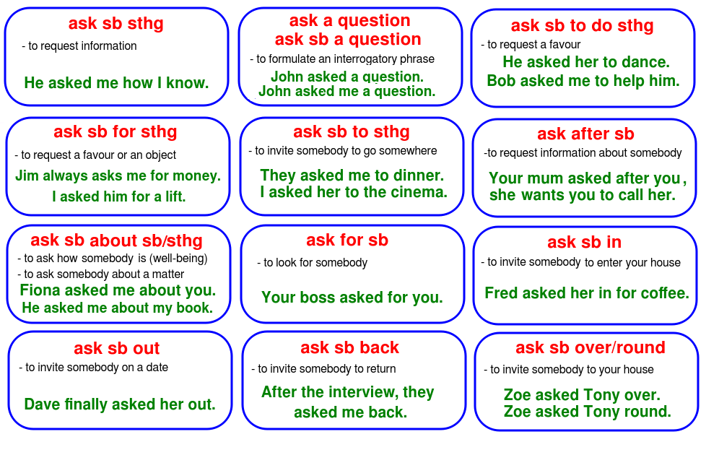

Key: sb – somebody Informal English: “That’s a big ask!”
sthg – something

