Phrasal verbs with “go”
( go / went / gone )

Phrasal verbs are verbs that are combined with one or two articles (usually a preposition or an adverb). Here are some examples using the verb “go”.

A) Physical movements

1) go up/down
to move vertically
The elevator went up to the twentieth floor.
The elevator went down to the ground floor.

2) go straight/ahead
to continue
Just go ahead for 2 miles and you will see it on the right.

3) go left/right
to turn left/right
You have to go left after one block, then go right.

4) go in/out
to enter/to exit
Every time I go in the house, I take off my shoes.
Let’s go out tonight. What do you prefer – cinema or restaurant?

5) go back
to return
I’ve forgotten my passport – we need to go back.

6) go around
to circumnavigate
You should go around the roundabout and take the third exit.

7) go under/over
to pass under/over
You go under the bridge then go left.
You go over the bridge then go right.

8) go through
to pass through
You need to go through the shop to get to the car park.

B) Other meanings

1) go away
to disappear Go away! You’re bothering me!
to travel Next year I think I’ll go away for one month.

2) go on
to continue I’m sorry about the interruption. Please go on.

3) go off
to sound My alarm goes off every day at 6am.
to spoil If you don’t put the milk in the fridge, it will go off.

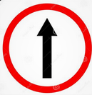
Exercise 1. Complete the following with phrasal verbs from above, conjugating as necessary.
1. Can you please __________________ to the house – I’ve forgotten my wallet.
2. You need to __________________ to the sixth floor. The apartment is 608.
3. (in a race) I can’t __________________. I’m exhausted!
4. Sorry – my car has broken down – you’ll have to __________________.
5. This meat stinks! I think that it has __________________.
6. My dog lives in the backyard – it never __________________ the house.
7. My house alarm __________________ at 5:20 this morning! But it was only a cat!
8. My son never __________________. He spends all of his time in his bedroom.
9. My boss __________________ twice a year – and always to Europe.

Exercise 2. Complete the following, using phrasal verbs and the images below.
To get to the library, you need to __________(1) , then __________(2), then __________(3) the bridge, then __________(4) the river. After that, you __________(5) for about a mile then you __________(6) the roundabout, taking the third exit. You’ll see the lighthouse on the right after about 100 meters. If you get to the lake, it means you went too far, so you’ll have to __________(7).
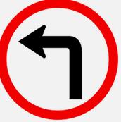
(1) (5)

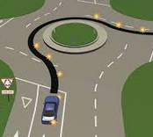

(2) (6)

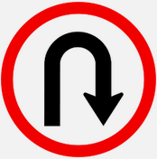
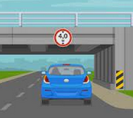
(3) (7)

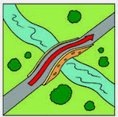
(4)

Recommended video (5 ways to use “go”):
https://www.youtube.com/watch?v=DWUOHLkZQeI (13 mins)

