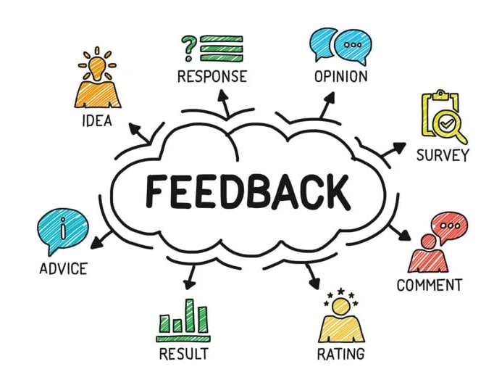
Feedback vs Feedforward

Feedback:
- Pinpoint the problem(s)
- Change attitudes
- Change habits

Feedforward:
- Anticipate problems
- Highlight the possibilities
- Make suggestions for the future

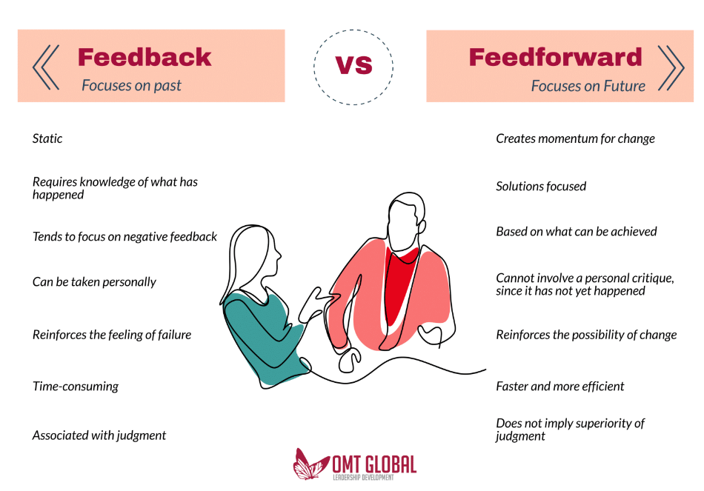

Source:
https://omtglobal.com/why-feedforward-works-better-than-feedback-in-managing-performance/

