Know Your Client (KYC)

KYC processes are employed by companies of all sizes for the purpose of ensuring that their clients, agents, consultants, suppliers and distributors are financially reliable and have a good reputation. The KYC processes allow you to verify a business and to manage risk. It includes:
- Verification of registration credentials;
- Verification of the business location;
- Verification of the UBOs (Ultimate Beneficial Owners) of the business;
- Investigation of any criminal activity (money laundering, terrorist financing, corruption, etc.)
- Verification that the business is not a fake entity.

Electronic KYC (eKYC)
This involves the use of the internet to verify the business information. For example:
- Validation of the business ID (eg. CNPJ);
- Validation of business address;
- Validation of personal IDs (eg passport, CPF).

Benefits of KYC
The “Know Your Client” (KYC) process helps your business in many ways:
- It reduces financial risk by identifying the previous financial history and assets owned;
- It limits fraud due to exposure of fake identities;
- It prevents money laundering and other anti-social activities;
- It brings stability and investment to your business;
- It makes your financial framework more trustworthy;
- Your business can attract more clients and therefore increase your profits.
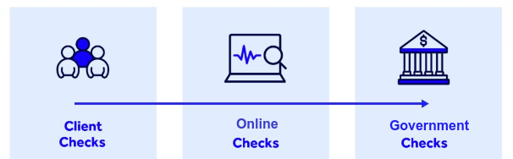

CIP, CDD EDD AML, RM

Processes:
- CIP Client Identification Process
- CDD Client Due Diligence
- EDD Enhanced Due Diligence
- AML Anti-Money laundering
- RM Remote Monitoring

