VUCA / BANI

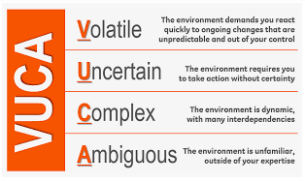
Today’s workplace is a complicated place. It can be difficult to make decisions and to advance.

It’s a BANI world:

BANI = Brittle, Anxious, Non-linear and Incomprehensible

FMEA = Failure Mode and Effects Analysis (Risk management)

