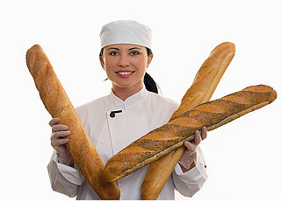
Vocabulary – Bread (in the UK)
The word “bread” in English is not countable, so we can’t say “breads”. So, how do we say “6 pães” in English? Well, we use adjectives to describe the type of bread, and other countable nouns to name the bread. The nouns “roll”, “loaf”, “baguette” and “stick” are all countable.
Here are some examples of different types of bread:
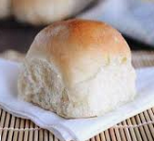
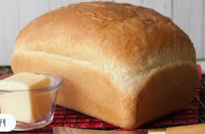
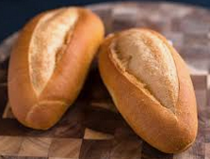

soft roll “French roll” white loaf

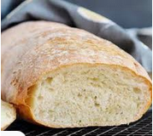
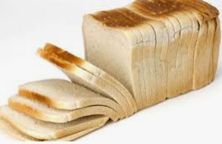
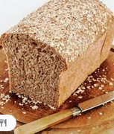

Italian loaf wholemeal loaf sliced loaf

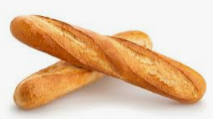
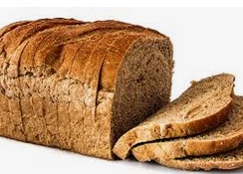

sliced brown loaf baguette “French stick”

Exercise. How do we say in English:
6 pães francês _________________________
pão de forma integral _________________________

Vocabulary – Bread (in the USA)

