English Vocabulary – Eggs
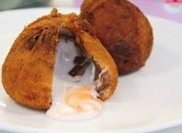
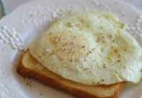
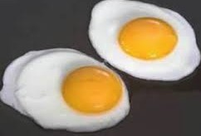

Fried egg – sunny side up Fried egg – over easy¹ Fried egg in batter
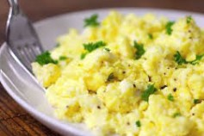
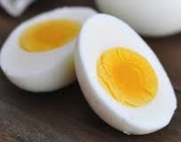
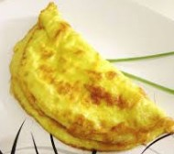

Omelet (USA) / Omelette (UK) Scrambled eggs Hard boiled egg


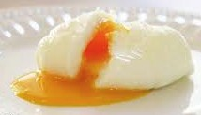

Soft boiled egg Poached egg (in water) Poached egg (in steam)
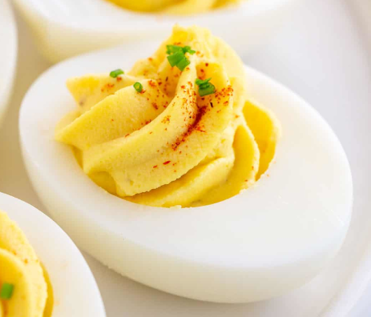
Notes:

1) Over easy: The egg is flipped and cooked for just a few seconds more, enough to fully set the white but leave the yolk runny.

Over medium: The egg is flipped and cooked for about a minute, enough to partly set the yolk but leave it a little creamy.

Over hard: The egg is flipped and cooked enough to fully set the yolk.

2) Deviled egg is a hard-boiled egg that has been shelled, cut in half, and filled with a paste made from the egg yolk mixed with mayonnaise and mustard. They are served cold as a side dish.

Deviled egg ²

