Grapefruit
The grapefruit is a citrus hybrid, resulting from the crossing of pomelo (Citrus maxima) with orange. This fruit is also known by the names of jamboa, watermelon orange and pamplemussa. The grapefruit was developed during the 18th century, probably in the Barbados region. Initially, the grapefruit was classified in the same species as the pomelo, but in fact, the grapefruit is a hybrid and its scientific name is Citrus x Paradisi.
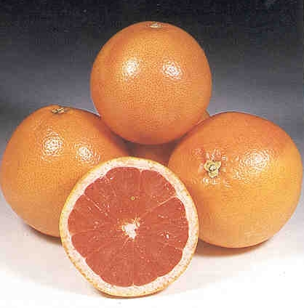


It’s commonly eaten for breakfast – cut in half and eaten with a spoon. It’s juice is quite bitter, so many people like to eat it with sugar sprinkled on it.

Grapefruit is one of those fruits that you either love or hate. The bitter, sour flavour also has a hint of sweetness, and is the perfect accompaniment to morning coffee.

The fruit contains vitamins, minerals, fibre and antioxidants, and it is excellent for your health if eaten regularly.

1) Grapefruit is extremely high in vitamin C (about 72 mg, or 120 percent of your daily value). Vitamin C makes your skin smoother, reduces wrinkles, and helps with sun damage. It also helps in the production of collagen, which helps provide healthy skin. Your immune system also benefits from vitamin C.

2) If you have high cholesterol, eat a grapefruit. In a study published in the Journal of Agricultural Food Chemistry, eating grapefruit daily helped lower “bad” levels of cholesterol by as much as 15 percent.

3) Grapefruit contains a lot of electrolytes, so it can prevent dehydration.

4) In a study published in the Journal of Medicinal Food, participants who ate half a fresh grapefruit before each meal experienced a significant reduction in both insulin levels and insulin resistance (which can lead to diabetes).

Source: https://tiphero.com/eat-grapefruit-every-day

