Herbs (Ervas) and Spices (Temperos)

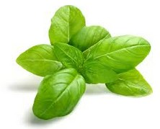  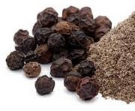  basil  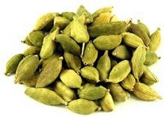  black pepper  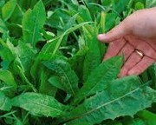  cardamom  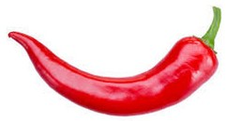  chicory  chilli (pepper)  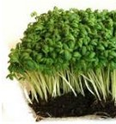  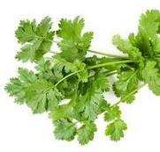  cilantro / coriander  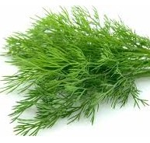  (water) cress  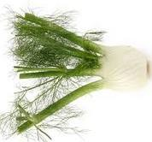  dill  fennel | 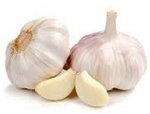  garlic  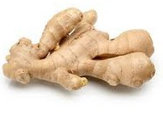  ginger  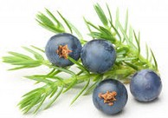  juniper berry  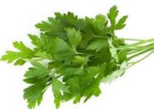  parsley  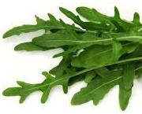  rocket  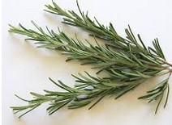  rosemary  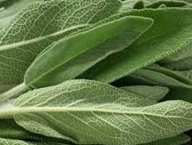  sage  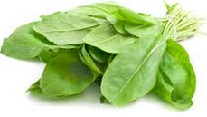  sorrel  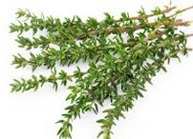  thyme

Translations:

basil  bay leaves  black pepper  cardamom  chicory  chilli (pepper)  cilantro/coriander  cumin seeds  (water) cress  dill  fennel  garlic  ginger  juniper berry  nutmeg  parsley  rocket  rosemary  sage  sorrel  thyme | manjericão  louro  pimenta do reino  cardamomo  chicória  pimenta em pó  coentro  cominho  agrião  endro  erva-doce / funcho  alho  gengibre  baga de zimbro  noz moscada  salsa  rúcula  alecrim  sálvia  miúda  tomilho

Song suggestion:
Simon and Garfunkel – Scarborough Fair (1966)
https://www.youtube.com/watch?v=jOFZ2Y4_1Jg
(Parsley, Sage, Rosemary and Thyme)

