English Vocabulary – Shopping

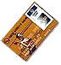
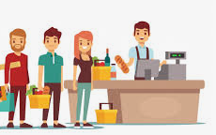  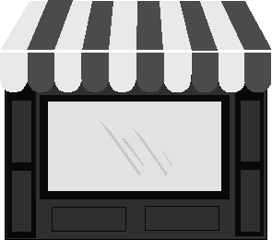 | 
Shop (UK) / Store (USA) | Customer | Cashier / Check-out
 | 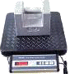 | 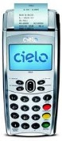
Wallet (M) / Purse (F) | Scales | PIN
 |  | 
Trolley (UK) / Cart (USA) | Basket | Changing Rooms (UK)  Fitting Rooms (USA)


Coins | Cash | Credit card / Debit card

Shopping Phrases/Questions

1) Finding a Shop/Store | 2) Opening Hours
Is there a supermarket near here?  Where can I buy toothpaste?  Where is the nearest shopping mall? | What time do you open?  What time do you close?  Are you open on Sundays?
3) Shopping for Clothes | 4) Paying
Can you help me?  I’m just looking.  Do you sell T-shirts?  Excuse me, I'm looking for scarfs.  Where can I find cellphones?  Can I try it on? (*)  Where are the changing rooms?  Do you have another size? (**)  Do you have different colors?  Is this in the sale? / Is this on sale?  Do you have my size? | How much is it?  Do you take Mastercard?  Can I get discount for cash?  I don’t need a bag.  Can you deliver?

* try on = provar
** Sizes: S / M / L / XL / XXL
Exercise 1 - Shopping Conversations

Conversation 1

Shop Assistant Customer
Good morning, madam. Can I _______ you? Yes please. I need a blouse.
_______, madam. What type of blouse? Cotton.
What _______? Red or pink.
What _______? Medium, please.
Here it is. Can I try it on?
Yes. The __________ are over there. Thanks.
……...
How is it, madam? It’s great. I’ll _______ it. How much is it?
It’s $42, madam. How would you like to _____? Cash. Do you take cash?
No, I’m sorry, madam, we don’t take cash. Oh. OK, I’ll pay by credit card. Here.
Thank you madam. Here is your blouse and invoice. Thank you.
Have a good _______, madam. Thanks. You, __________.

Conversation 2

Shop Assistant Customer
Good afternoon, sir. Can I _______ you? No, thanks. I’m just ___________.
Of course, sir. If you need any help, just call me. Thanks.

Conversation 3

Shop Assistant Customer
Good evening, sir. Can I _______ you? Yes. I want some jeans.
OK sir. What _______? Black. Do you _______ black?
I think so. One _______, please.
…….
Here they are, sir. Black jeans.
Would you like to _______ them on? Yes. Where are the changing _______?
Just over there. Thanks.
…….
How are the jeans, sir? Fantastic. I’ll take them. How _______?
$129. How would you like to _______? American Express.
I’m sorry, sir, we don’t take Amex. Oh. OK. Mastercard?
No problem. Please enter your _______.
Here are your jeans and _______. Thank you.
Have a _______ day, sir. You, too.

Supermarket – Quantities
Singular / Countable
a banana, strawberry, pie, tomato, ...
an apple, orange, egg, onion, ...

Plural / Countable
some grapes, oranges, eggs, bananas, tomatoes, sausages, carrots, ...

Uncountable
some milk*, orange juice, beer, coffee, rice, bread, honey, chocolate
(* long life / fresh milk, whole milk / full cream, reduced fat / semi-skimmed,
fat-free / skimmed, lactose-free, powdered)

Containers (countable) Examples
a bottle of … (garrafa) wine, olive oil, lemonade
a carton of … (caixa/caixinha) (líquidos) milk, orange juice
a box of … (caixa) (bens secos) eggs, matches, cereal
a jar of ... (pote de vidro) honey, jam
a bar of … (barra) chocolate, soap, butter
a bag of … (sacola/sacolinha) sugar, rice, flour
a packet of … (pacote) cigarettes, biscuits
a can of … (lata) (líquidos) Coca-Cola, Fanta
a tin of … (lata) (bens secos) biscuits
a pot of … (potinho) yogurt, cream cheese
a tube of … (tubo) toothpaste, glue
a tub of … (pote)(plástico) margarine, strawberries, ice-cream
a sachet of … (sachê) ketchup, mayonnaise
a multi-pack of … (bandeja) yogurt, beer
a kilogram / kilo of … potatoes, carrots, oranges
a loaf of … bread (pão de forma)

Supermarket units:

Weight: lb (pound), oz (ounce), g (gram), kg (kilogram)

Volume: gal (gallon), pt (pint), lt (liter), cl (centiliter), ml (milliliter)
Exercise 2: Describe the items.
Examples: a multi-pack of yogurt, a box of napkins, a box of chocolates,. etc.
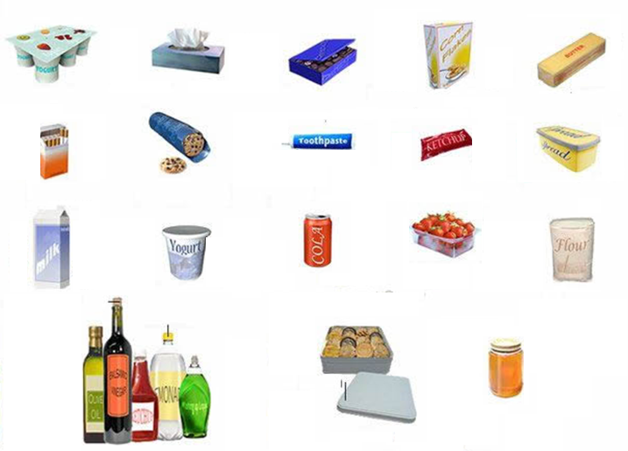

Shopping in the supermarket in the USA:
https://www.youtube.com/watch?v=EZ2iYEdroS8 (10 mins)

Shopping in the supermarket in the UK:
https://www.youtube.com/watch?v=_AiO2U7Prwc (13 mins)

Shopping in the supermarket in Canada:
https://www.youtube.com/watch?v=NG-de6quWkE (5 mins)

Exercise 3: I would like ……. and …….
 | a loaf of bread | 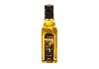 | a bottle of  olive oil
 | 1 kg of apples | 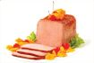 | some ham
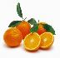 | some oranges | 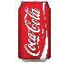 | a can of  Coca-Cola
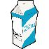 | a carton of milk |  | a watermelon
 | a cake | 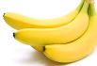 | some bananas
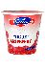 | some yogurt |  | an ice-lolly
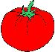 | some tomatoes | 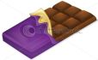 | a bar of  chocolate
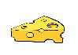 | some cheese | 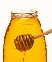 | a jar of  honey
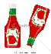 | a bottle of ketchup | 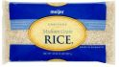 | a bag of rice
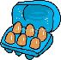 | a box of eggs | 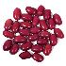 | a bag of beans
 | some beer | 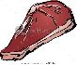 | 1 kg of beef
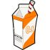 | a carton of  orange juice | 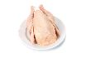 | a frozen chicken
 | a coconut | 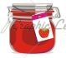 | a jar of jam

