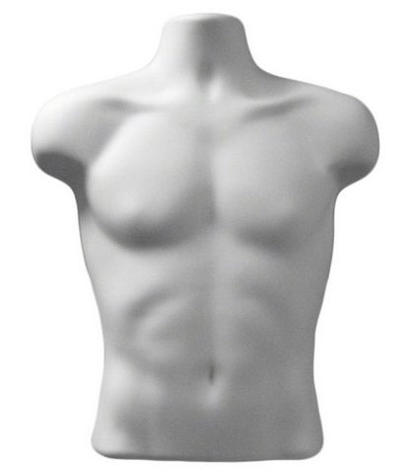
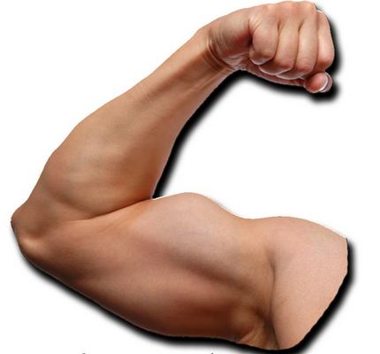
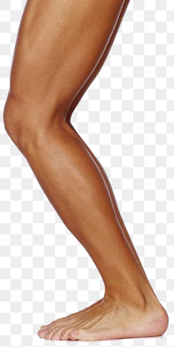
English Vocabulary – The Body

Name some parts of the head:
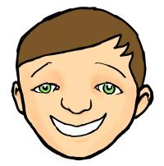
h________
n________
e________
e________
m_______
t________

Name some parts of the torso:
c________
s________
h________
b________
s________
n________

Name some parts of the arms and legs:
t________ e________
h________ c________
k________ f________
f________ t________
w________ a________

(answers on last page)
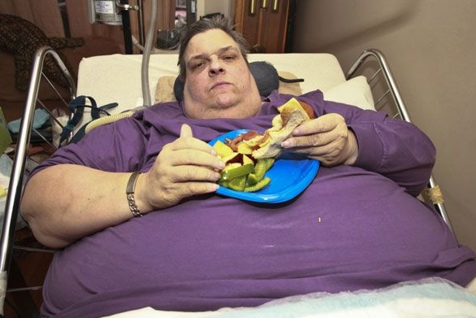
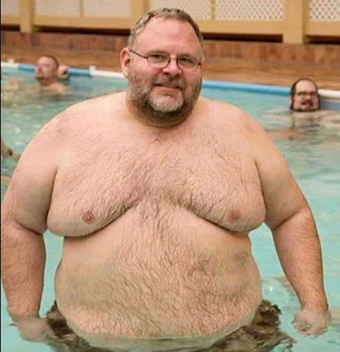
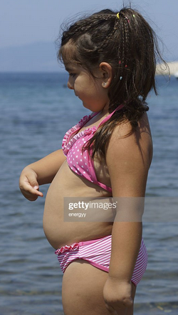
Body sizes:

obese

fat

chubby


slim
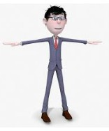

thin/skinny



anorexic
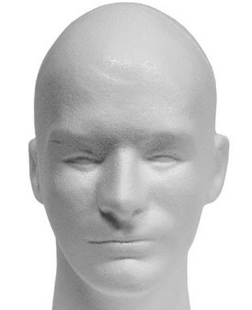
English Vocabulary – Answers

Name some parts of the head:
hair
nose
eyes
ears
mouth
teeth

Name some parts of the torso:
chest
shoulders
hips
belly-button
stomach
neck

Name some parts of the limbs:
arms toes
legs hands
knees fingers
feet thighs
wrists ankles
elbows calves

