English Vocabulary – Health Club/Gym
1. Asking about membership options
Can you tell me about…
I'd like some information about…
Do you have any special introductory packages?
What sort of membership options do you have?
How often can I use the gym with this membership?

2. Asking about cost
How much does membership cost?
Do I have to pay every time I use the gym?

3. Saying what your interests are
I'd like to lose weight / get fit / tone up / build stamina / increase muscle
What do you suggest for losing weight / getting fit / toning up / building stamina / increasing muscle?

4. Asking about classes
Do you run any classes?
How many times a week is there a kick-boxing / pilates / yoga session?
Is there a waiting list for kick-boxing / pilates / yoga?
Do I need a medical certificate for these classes?

5. Asking about the facilities
What facilities do you have?
Can you show me how to use the equipment?
When is the quietest time to use the gym?
What are your opening and closing times?
Are you open at the weekend as well?

At the Gym
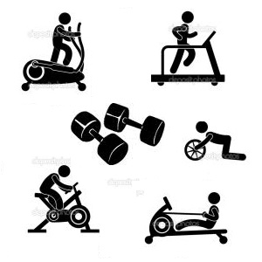
Equipment
- Dumbbell
- Exercise bike
- Treadmill
- Skipping rope
- Trampoline
- Bench
- Mat
- Multi-function gym

Movements
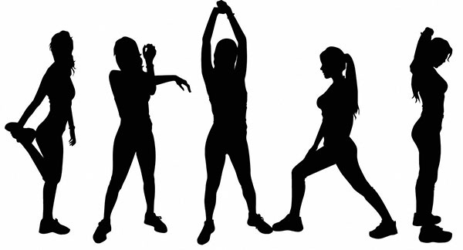
- Sit (down)Stand (up)
- Kneel (down)
- Lie (on your back/front)
- Crouch
- Squat
- Stretch (stretching)
- Put/Place
- Turn/Twist
- Lift

Other vocabulary
- Keep/Hold
- Look (straight ahead, down, up, to the left/right)
- Continue
- Repeat
- Straight
- n times (once, twice, 3 times, 4 times, etc.)
- Touch
- Bend/Flex
- Push/Pull
- Rest for __________
- Shape (get in / keep in)

Practice
1. Put your hands on your hips. Look straight ahead. Twist your body to the left, then to the right. Repeat 10 times.
2. Sit on the floor with your legs straight. Stretch your arms and touch your toes. Hold for 30 seconds.
3. Sit on the floor with your legs straight. Place your right foot on your left thigh. Hold your right shin with both hands. Hold for 10 seconds. Repeat with the other leg.
4. Open your legs a little. Bend your knees a little. Place your hands behind your back, joining your fingers together. Stretch your arms and push them up as high as you can. Hold for 10 seconds. Repeat 6 times.
5. Place your right hand on your left shoulder, and your left hand on your right shoulder. Keep your legs straight. Bend down as far as you can. Hold for 10 seconds. Repeat 5 times.

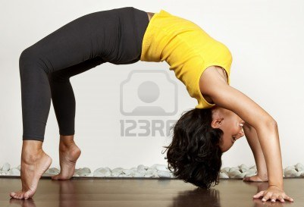

Conversation practice
Conversation 1
A: "What do you do besides work and watching TV?"
B: "When I have some time, I like to exercise."
A: "Do you go jogging or do you go to a health club?"
B: "I joined EasyLife Health Club a couple of months ago."
A: "What kind of exercise do you do there?"
B: "I usually spend 30 minutes on the exercise bike for some cardio work, then I lift weights for about 45 minutes."
A: "How often do you go?"
B: "I’d like to go four times a week, but I'm a little lazy. Last week, I only went once."

Conversation 2
A: "Hey Jimmy. Let's work out later today."
B: "Sure. What time do you want to go?"
A: "How about 3:30.?"
B: "That sounds good. Let’s work on legs and forearms today."
A: "Hey. I just played basketball earlier, so my legs are a little sore. Let's work on arms and stomach instead."
B: "Alright. See you later."

Conversation 3
A: "Wow, Scott - you got muscles!"
B: "Yeah, I've been working out a lot."
A: "How long have you been lifting weights?"
B: "For a year and a half."
A: "Last time I saw you, it was like 2 years ago."
B: "Yeah. I decided that I really needed to get in shape."
A: "How often do you go to the gym?"
B: "I usually go every other day for about 3 hours."
A: "That's a lot."
B: "Yeah, I used to work out for an hour a day, 4 times a week, but I didn’t see any results."
A: "I don't think I have the self-discipline for that."
B: "Just think of it as a hobby. Then it's actually fun."

Stretching Exercises
