The English Alphabet
a = êi | b = bí | c = cí | d = dí | e = í | f = éf
g = djí | h = êitch | i = ái | j = djêi | k = kêi | l = él
m = ém | n = én | o = ôu | p = pí | q = quíu | r = ár
s = éss | t = tí | u = iú | v = ví | w = dâbliu | x = éks
y = uái | z = zí (USA) | z = zéd (UK)
Source: https://www.languageguide.org/english/alphabet/
The Alphabet Song
https://www.youtube.com/watch?v=75p-N9YKqNo

A, B, C, D, E, F, G
H, I, J, K, L, M, N, O, P
Q, R, S, T, U and V
W, X, Y and Z
Now I know my ABCs
26 letters from A to Z

Exercise 1. Write an English word for each letter of the alphabet:

A | B | C | D | E
F | G | H | I | J
K | L | M | N | O
P | Q | R | S | T
U | V | W | X | Y
Z
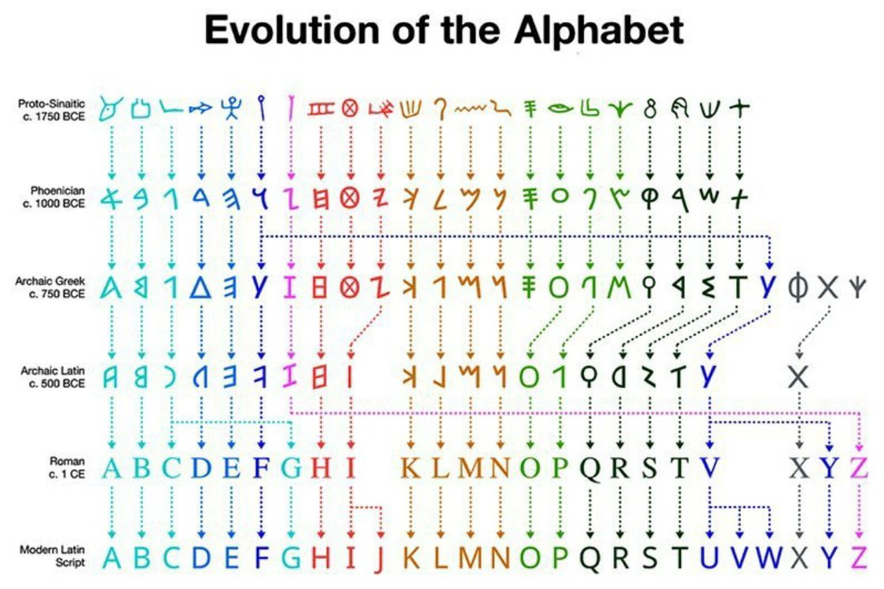
Exercise 2. Practise saying the following acronyms:

BBC USA UN PT UK CNN GNT

CD DVD TV LCD LED RGB LOL

TNT HSBC BSB LHR LGW H2O CO2

Exercise 3. Practise spelling your name.

Exercise 4. Spell the following words:

exercise tomorrow yesterday jogging yellow Monday

Exercise 5. Listen to the teacher say a word and spell it for him/her.

Suggested video:
Alphabet conversation: https://www.youtube.com/watch?v=h-mX9T2qyIQ

