English Vocabulary – Clothes (verb: to wear)

Masculine (M) | Feminine (F) | Both (M & F) | Footwear | Accessories
shirt  suit  tie  briefs  boxers  pants (UK)  blazer  tuxedo | blouse  top  skirt  short skirt  dress  bra  panties | sweater  fleece  cardigan  T-shirt  polo shirt  shorts  jacket  coat  pants (USA)  trousers (UK)  socks  belt  gloves  scarf  hat / cap / beanie | shoes  sneakers (USA)  trainers (UK)  tennis shoes  sandals  boots  flip-flops  slippers  high-heels | bracelet  watch  necklace  earrings  glasses sunglasses  ring  wedding ring  purse  handbag

Materials: leather, cotton, polyester, silk, suede, satin, wool, nylon, linen, denim
Patterns: plain, polka-dot, striped, check/plaid/tartan, flowered
Note: We usually use the following order: color – pattern – material – object
Examples: a blue tie black shoes
a blue silk tie black leather shoes
a blue striped tie black striped pants
a blue striped silk tie black striped cotton pants
More examples:
What is he wearing?
He is wearing a red plain cotton polo shirt.
He is wearing black cotton pants and brown leather shoes.
He is wearing a check wool sweater, a white cotton shirt and a green silk tie.
He is wearing a blue striped polyester suit, a red tie and black leather shoes.

What is she wearing?
She is wearing an orange and white check cotton skirt and a beige satin blouse.
She is wearing a black plain dress and high-heels.
She is wearing a red nylon skirt, a pink polka-dot cotton blouse and white socks.

Exercise 1.
Q. What do you usually wear at work? A. I usually wear ___________ .
Q. What do you usually wear at home? A. I usually wear ___________ .
Exercise 2: What is he/she wearing?

A B C D
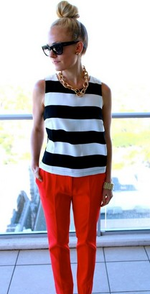
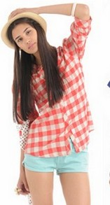
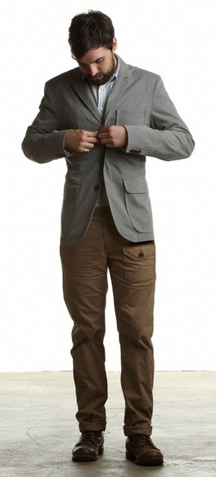
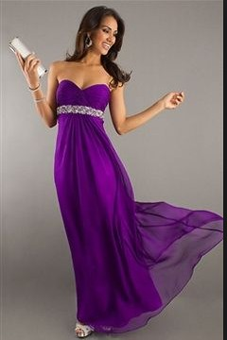

A. He is wearing ....
______________________________________________________________

______________________________________________________________

B. She is wearing .... ______________________________________________________________

______________________________________________________________

C. She is wearing .... ______________________________________________________________

______________________________________________________________

D. She is wearing .... ______________________________________________________________

______________________________________________________________

