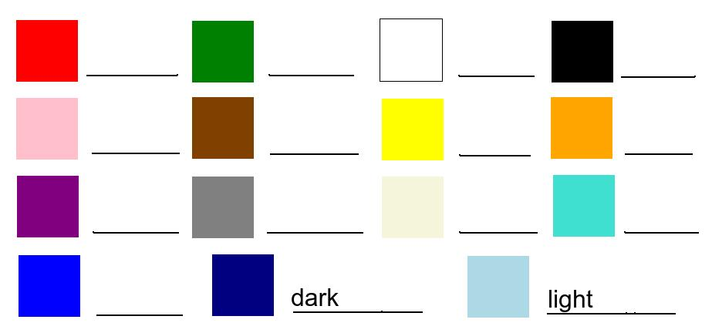
English Vocabulary – Colours (UK) / Colors (USA)

