English Vocabulary – Dimensions / Size / Power

Adjectives | Nouns | Verbs (regular)
wide  narrow | width  ---- | to widen  to narrow
long  short | length  ---- | to lengthen  to shorten
high  low | height  ---- | to heighten/raise  to lower
deep  shallow | depth  ---- | to deepen  ----
weighty  weightless  light  heavy | weight  weightlessness  lightness  heaviness | to weigh  ---  to lighten  ---
strong  weak | strength  weakness | to strengthen  to weaken
thick  thin | thickness  ---- | to thicken  to thin

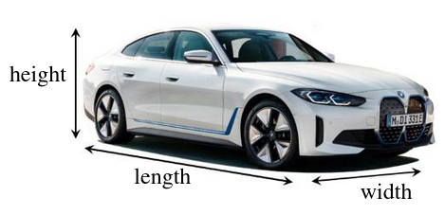
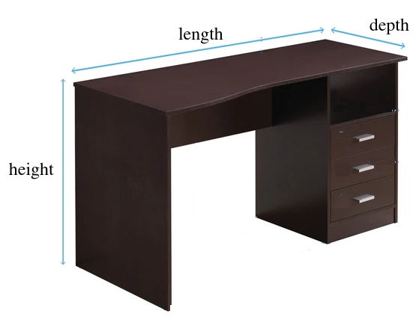
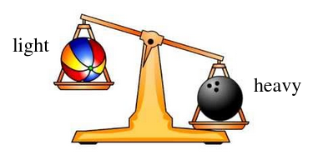
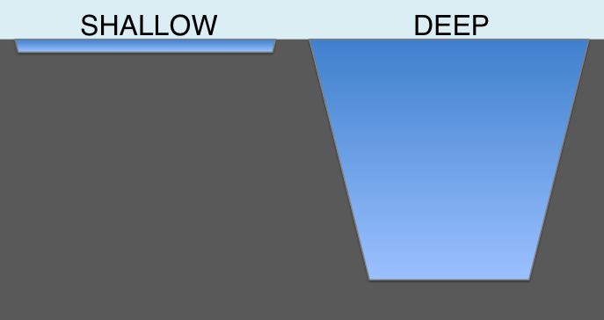
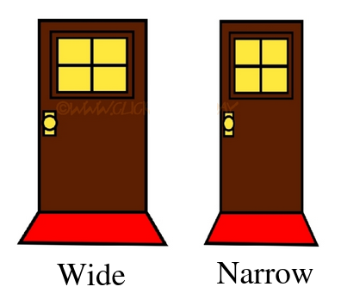
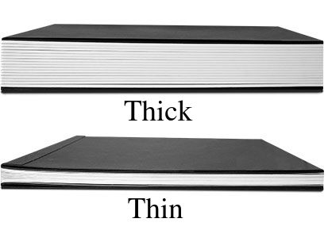
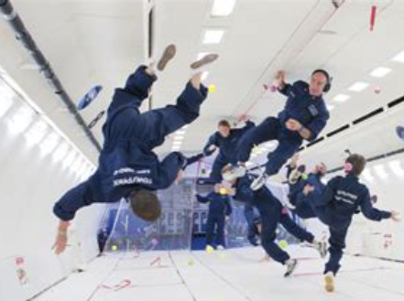
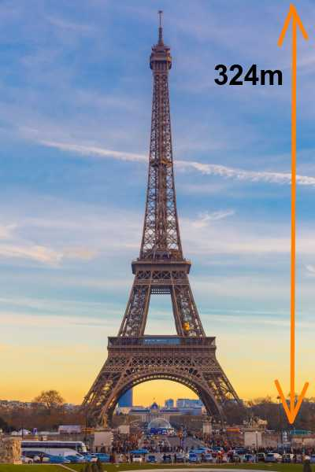
Examples

The following examples all use physical contexts, but many of the words can be used in abstract contexts too.

For example: My swimming pool is deep. (physical context)
My love for her is deep. (abstract context)

Adjectives
1. My swimming pool is 5m wide, 12m long and 2m deep.
2. My swimming pool is shallow at one end and deep at the other.
3. The river is narrow and shallow – big ships can’t pass.
4. My baggage is weighty.
5. Astronauts in space are weightless.
6. My bicycle is very light. It’s made from aluminium.
7. A sack of cement is heavy.
8. Spider webs are extremely strong and thin.
9. MDF is a weak material.
10. I prefer short pants in the summer
and long pants in the winter.
11. The bridge is low – buses can’t pass.
12. The trunks of high trees are usually thick.

Nouns
1. The maximum depth of the Pacific Ocean is 11,022 meters.
2. The width of my garage is 1 meter more than the width of my car.
3. The height of the Eiffel Tower is 324 meters.
4. The length of an adult blue whale is about 25 meters.
5. The maximum weight allowed for each bag is 32kg.
6. Astronauts in flight experience weightlessness.
7. Light alloy has the strength of steel and the lightness of aluminium.
8. Olivia was worried about the heaviness of her backpack.
9. Finding the weakness of your opponent is the secret to winning.
10. The thickness of a human hair is approximately 70 microns.


Verbs
1. Air companies must weigh every bag that they put on an airplane.
2. I would like to widen my garden path.
3. The council want to narrow the road where I live as part of a traffic-slowing initiative.
4. The teacher told Lucy to lengthen her skirt, because it was too short.
5. I had to shorten my new jeans, as I have short legs.
6. Some drugs heighten your emotions.
7. My son asked me to raise the basketball net.
8. I had to lower the garden swing for my young son.
9. We need to deepen the hole to plant this tree.
10. I removed the encyclopedia to lighten my backpack.
11. Iron rods are used in concrete to strengthen buildings.
12. A lot of sugar can weaken the enamel on your teeth.
13. When making white sauce, add milk to thin it,
or flour to thicken it.

