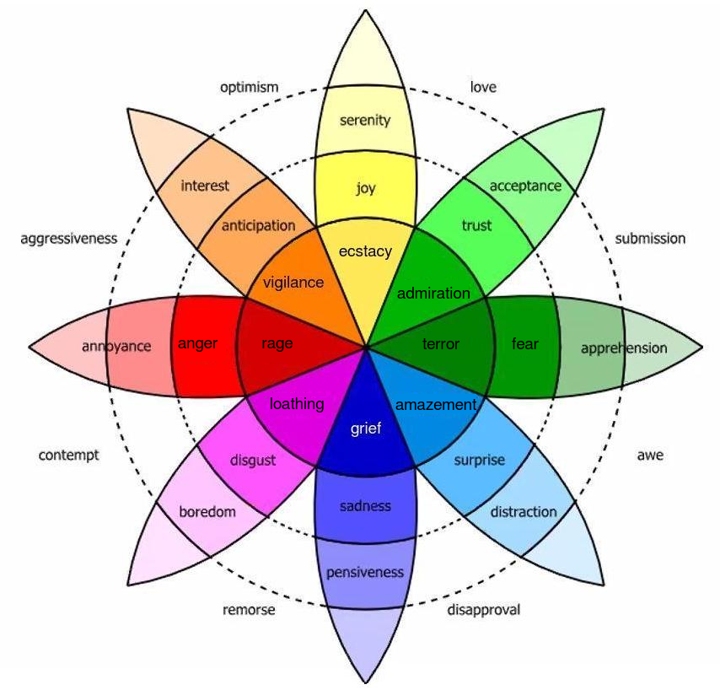
English Vocabulary – Emotions

The Emotion Continuum – Nouns

The Emotion Continuum – Adjectives

optimistic serene apprehensive pensive annoyed
loving joyful fearful sad angry
submissive ecstatic terrified grief-stricken raging
awesome accepting distracted bored interested
disapproving trustful surprised disgusted anticipative
remorseful admirable amazed loathsome vigilant
contemptuous aggressive

