English Vocabulary – Family & Relatives

Masculine | Feminine | Both
father / dad / daddy / pa | mother / mom / mommy / mum / mummy / ma | parents
son | daughter | children / kids
brother | sister | siblings
uncle | aunt | ------
nephew | niece | ------
cousin | cousin | cousins
grandfather / grandpa | grandmother / grandma | grandparents
grandson | granddaughter | grandchildren / grandkids
great grandfather | great grandmother | great grandparents
great grandson | great granddaughter | great grandchildren /  great grandkids

Relatives gained by first marriage:

Masculine | Feminine | Both
husband / spouse | wife / spouse | spouses
brother-in-law | sister-in-law | ------
father-in-law | mother-in-law | parents-in-law
son-in-law | daughter-in-law | ------

Relatives gained by second marriage:

Masculine | Feminine | Both
stepfather | stepmother | step-parents
stepson | stepdaughter | stepchildren  (step-family)
stepbrother | stepsister | step-siblings

Relations that don't exist (!):

stepwife, stephusband
wife-in-law, husband-in-law

Online exercise: https://www.englishclub.com/vocabulary/family-quiz.htm
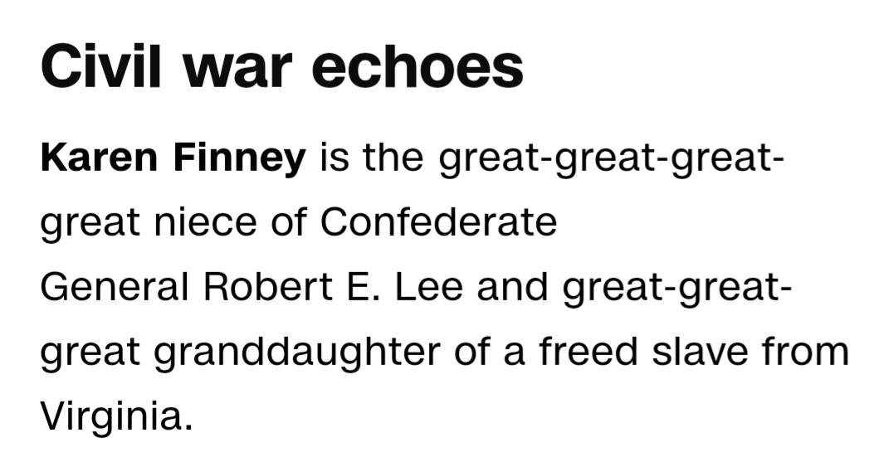
Extract from a CNN news article, January 2024:
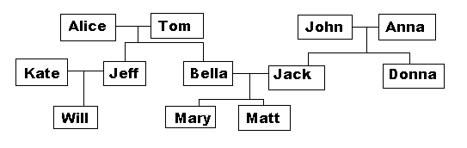
Exercise 1: Look at the family tree and complete the sentences.

Note: Bob’s = “do Bob” / Mary’s = “da Mary” (possessive)
- Tom is Jeff’s ______________. Jeff is Tom’s ______________.
- Alice is Tom’s ______________. Tom is Alice’s ______________.
- Matt is Will’s ______________. Will is Matt’s ______________.
- Jeff is Bella’s ______________. Bella is Jeff’s ______________.
- Anna is Mary’s ______________. Mary is Anna’s ______________.
- Who is Bella’s nephew? It is ______________.
- Kate is Bella’s ______________. Bella is Kate’s ______________.
- Bella is John’s ______________. John is Bella’s ______________.

Exercise 2: Bob divorced his first wife and then married Susan.
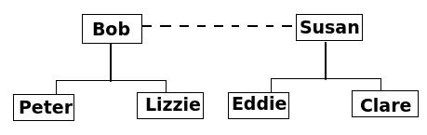

a) Bob is Eddie’s ________________. Eddie is Bob’s ________________.
b) Clare is Bob’s ________________. Bob is Clare’s ________________.
c) Peter is Clare’s ________________. Clare is Peter’s ________________.
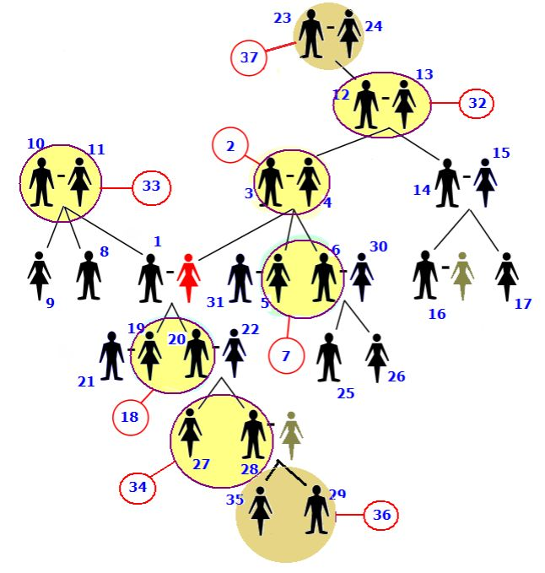
Exercise 3.

Analyze the diagram and complete the table on the next page. Note that all relationships are from the perspective of the red figure (the two green figures don’t have relationship names in English). A hyphen represents marriage. For example 23 is married to 24.

 | Name of Relative |  | Name of Relative
1 |  | 21
2 |  | 22
3 |  | 23
4 |  | 24
5 |  | 25
6 |  | 26
7 |  | 27
8 |  | 28
9 |  | 29
10 |  | 30
11 |  | 31
12 |  | 32
13 |  | 33
14 |  | 34
15 |  | 35
16 |  | 36
17 |  | 37
18
19
20

Exercise 4.
Paul and Mary had a baby boy on January 2nd. Their new son Christopher weighs 5 kg. He has a sister Rachel, 6, and a brother Malcolm, 4. Christopher's uncle Jim and aunt Kathy were present at his birth. His grandparents, Lisa and Mike, were also present. His cousins Jerry, Fern, and Lindsay are very excited to see baby Chris! They will come to visit soon! Christopher’s proud parents would like to thank everybody for their wonderful gifts.

1. What is Christopher's mother's name? _________________________
2. Who are Christopher's siblings? _________________________
3. Who is Kathy? _________________________
4. Who will come to see Chris soon? _________________________
5. Who is Kathy in relation to Mary? _________________________

