English Vocabulary: Football (UK) / Soccer (USA)

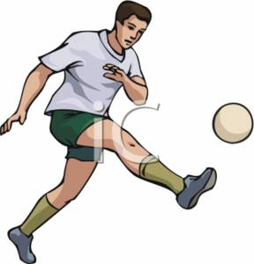  People  eleven players  two teams / sides  coach / manager  referee / linesman  substitute / reserve  defender / attacker  goalkeeper (goalie)  fan / spectator / supporter (to support) | 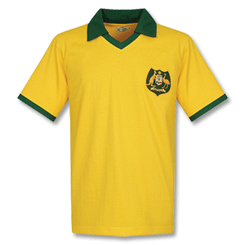  Things  stadium  field / pitch  ball  goal / net  posts / crossbar  corner flag  red card / yellow card  whistle  shirt / shorts / socks / boots  shin pads
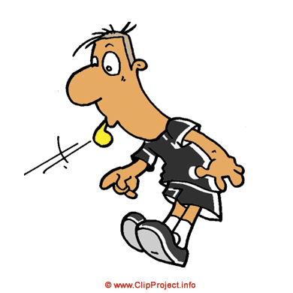  Rules  free kick  goal kick  corner kick  foul  offside  penalty / penalties  to blow the whistle  to call a foul  to receive a red card / yellow card  to send off / to be sent off  The World Cup  champion / championship  to classify / qualifiers  first round / second round  quarter-finals / semi-finals / final | The Game / The Match  to play / to face (an opponent)  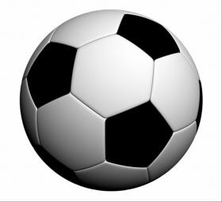  kick off  to kick / to shoot  to toss a coin  to score / get a goal  to cross / to pass / to dribble  to take a corner  to sit on the bench  to win / to lose  to win on penalties  to turn the game  to take control of the game  the winner / the loser  victory / defeat  to beat / to defeat (the opponent)  football league
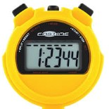  Time  first half  second half  half time  full time  injury time  extra time | 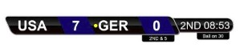  The Score  three-nil  seven-one  “They won by two goals to one”  two-two / two all  to draw / to tie / a draw / a tie  goal difference  half-time score  final score

Verb conjugation: win / won, lose / lost, beat / beat, draw / drew, blow / blew
send / sent, take / took, sit / sat
(all other verbs are regular)
Exercise. Translate to English:

12 de julho de 2018. A Croácia venceu a Inglaterra por 2 a 1
Mario Mandzukic destrói o sonho da Inglaterra na Copa do Mundo na semifinal.
A Croácia enfrentará a França na primeira final de uma Copa do Mundo.
A Inglaterra enfrentará a Bélgica na disputa do terceiro lugar.

A Croácia venceu Inglaterra por 2 a 1 e se classificou, pela primeira vez na história, para a final da Copa do Mundo. Trippier abriu o placar, Perisic empatou no segundo tempo e Mandzukic virou na etapa final da prorrogação. Agora, os croatas enfrentam a França na final do Mundial, no próximo domingo. Depois do primeiro gol, os croatas tomaram conta do jogo, acertando a trave e dando trabalho ao goleiro Pickford. O empate levou a partida para a prorrogação, onde a Inglaterra foi superior no primeiro tempo, mas os croatas viraram a partida aos três minutos do segundo tempo. A pressão final inglesa não mudou o placar, que terminou em 2 a 1.

________________________________________________________________________
________________________________________________________________________
________________________________________________________________________
________________________________________________________________________
________________________________________________________________________
________________________________________________________________________
________________________________________________________________________
________________________________________________________________________
________________________________________________________________________

