English Vocabulary – Furniture

Exercise 1. Name the items.
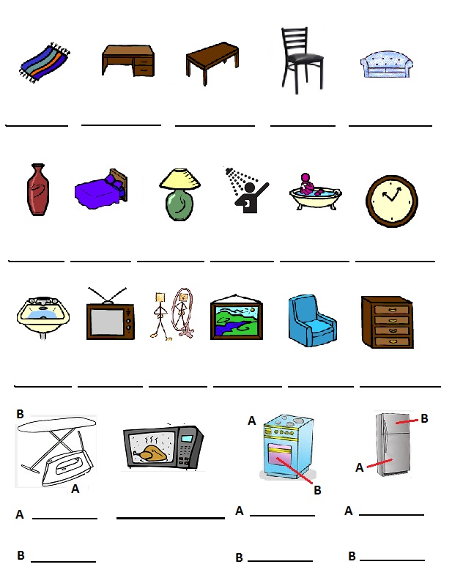

Exercise 2. Translate.
armário __________________
guarda-roupas __________________
vaso sanitário __________________
máquina de lavar __________________
mesa de jantar __________________
lareira __________________

