Homonyms - One word, two meanings
(from Latin: “homo”=”same”, “nym”=“name”)

Homonyms are words that are written the same and sound the same but have different meanings. In other words, a homonym is a word that has two or more meanings, even though it looks and sounds the same. Here are some examples:

Homonym | Meaning 1 | Meaning 2
address | to deal with | street location
band | a musical group | a ring
bark | the outside part of a tree | the sound a dog makes
bat | a wooden stick used to hit a ball | a nocturnal flying mammal
book | something to read | to make a reservation
brilliant | smart or intelligent | strong light
current | up to date | flow of water or electricity
die | to stop living | a cube marked one to six (plural: dice)
express | a fast version of something | to describe your thoughts
fair | just | a small market
fan | cooling machine | somebody who likes something a lot
flies | flying insects | third person present simple of ‘to fly’
kid | a child | a baby goat
kind | a type of something | gentle
lie | to recline | to say something not true
match | a sports game | a stick to make fire
mean | to signify | average
metal | hard substance | a genre of music
miss | to feel sad in someone’s absence | to not attend a commitment
pen | a writing instrument | a holding area for animals
pole | a piece of metal that holds a flag | extreme point on a planet
right | correct | opposite of left
rock | a genre of music | a big stone
rose | the past simple of ‘to rise’ | a flower
spend | to buy something with money | to pass time
stalk | the strong part of a flower | to follow or harass someone
tire | to become weary | part of a wheel
well | in good health | a source of water in the ground

Source: https://examples.yourdictionary.com/examples-of-homonyms.html

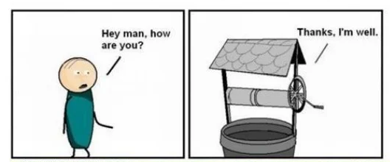
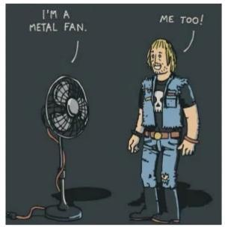
Some homonym jokes:

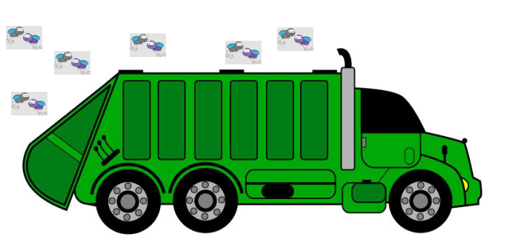
Q: What has six wheels and flies? A: A garbage truck.
Some Portuguese examples of homonyms (homônimos):

Caminho
- Eu sei qual o caminho para chegar até lá.
- Eu caminho cerca de meia hora para chegar.

Cedo
- Saí mais cedo do que nos demais dias.
- Sempre cedo quando sou pressionado.

Leve
- Esta caixa está leve.
- Você quer que eu leve estas caixas?
- Leve a vida leve!

Manga
- Eu adoro manga. É deliciosa!
- A manga esquerda da minha jaqueta está rasgada.

Morro
- Eu sempre subo um morro para chegar ao trabalho.
- Eu morro de medo de ratos.

Rio
- Na trilha visitamos um belo rio.
- Eu rio demais das piadas que ele faz.

São
- Ele está são e salvo!
- Vocês dois são impossíveis!

Torta
- Adoro torta de chocolate.
- A peça está torta.

Vão
- Nunca diga o nome do Senhor em vão.
- Eles vão ao parque rodo dia.
- Há um grande vão entre os pilares.

Verão
- Vou viajar durante o verão.
- Não sei se eles verão quando eu chegar.

