English Vocabulary - House & Garden
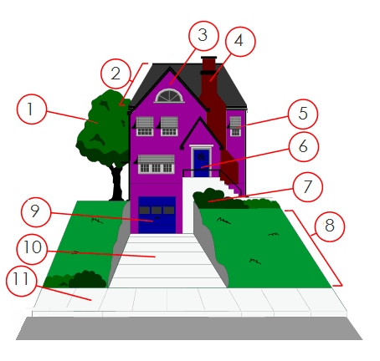

1
2
3
4
5
6
7
8
9
10
11

