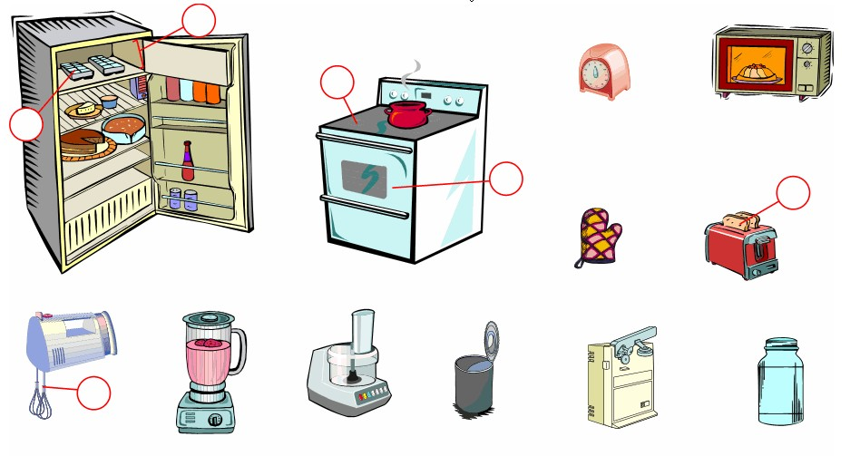
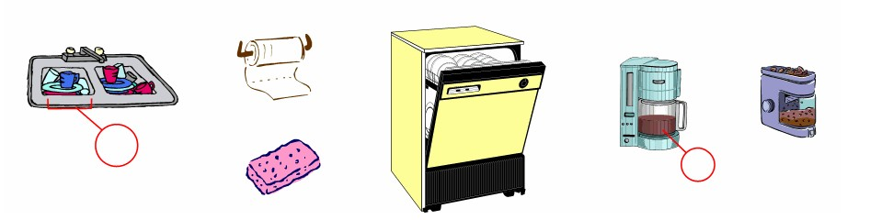
English Vocabulary – Kitchen
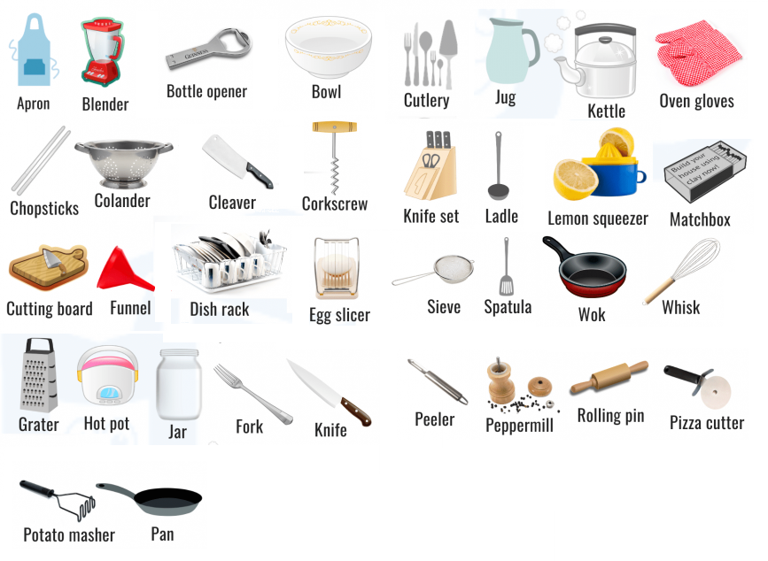
English Vocabulary – Kitchen Utensils

