English Vocabulary – Money

US$ 10.00 Ten dollars (USA: dollars, cents)

€ 17.00 Seventeen euros (Europe: euros, cents)

£ 23.00 Twenty three pounds (UK: pounds, pence)

US$ 10.50 Ten dollars and fifty cents
or Ten dollars, fifty
or Ten, fifty

€ 17.25 Seventeen euros and twenty five cents
or Seventeen euros, twenty five
or Seventeen, twenty five

£ 23.99 Twenty three pounds and ninety nine pence
or Twenty three pounds, ninety nine
or Twenty three, ninety nine

Exercise – write the money values in words:

1) US$ 20.00 _____________________________________

2) € 88.00 _____________________________________

3) £ 62.00 _____________________________________

4) US$ 20.40 _____________________________________

5) € 88.10 _____________________________________

6) £ 62.35 _____________________________________

7) US$ 120.00 _____________________________________

8) € 250.00 _____________________________________

9) £ 199.99 _____________________________________

Coins Bills (USA) / Notes (UK)

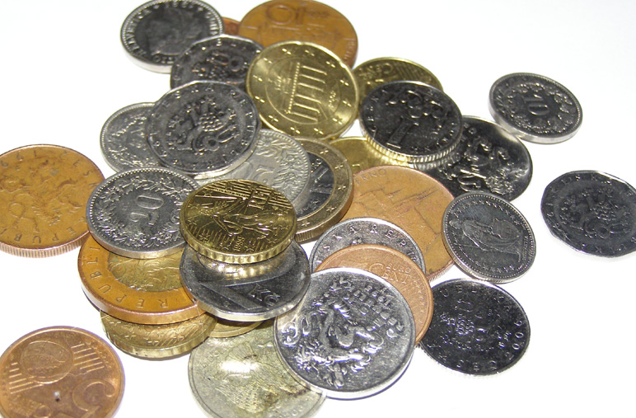
Currency ATM (USA) / Cash machine (UK)
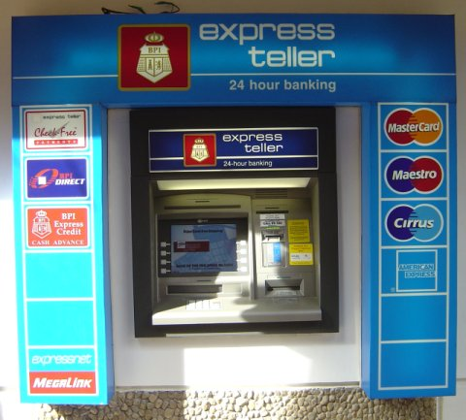
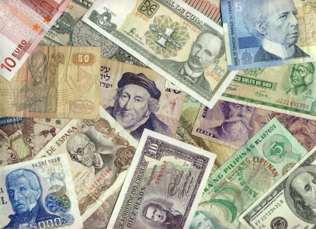
Country Currency

Names for US money:

$1 – a dollar/buck
50 cents – a half dollar
25 cents – a quarter
10 cents – a dime
5 cents – a nickel
1 cent – a penny

Australia Australian Dollar
Brazil Real
Canada Canadian Dollar
China Renminbi
Denmark Danish Krone (plural: Kroner)
India Rupee
Japan Yen
New Zealand New Zealand Dollar
Norway Norwegian Krone (plural: Kroner)
Paraguay Guarani
Peru Sol
Russia Ruble
South Africa Rand
Sweden Swedish Krona (plural: Kronor)
Switzerland Swiss Franc
UK Pound Sterling
Venezuela Bolivar

Countries which use the US Dollar:
USA, Ecuador, El Salvador, Panama, Zimbabwe, Timor-Leste, Micronesia, Palau, Marshall Islands, Puerto Rico, Guam, U.S. Virgin Islands, Northern Mariana Islands, American Samoa, British Virgin Islands, Turks and Caicos Islands

Countries which use the Peso:
Argentina, Bolivia, Chile, Columbia, Mexico, Uruguay

Countries which use the Euro:
Austria, Belgium, Cyprus, Estonia, Finland, France, Germany, Greece, Ireland, Italy, Latvia, Lithuania, Luxembourg, Malta, The Netherlands, Portugal, Slovakia, Slovenia, Spain
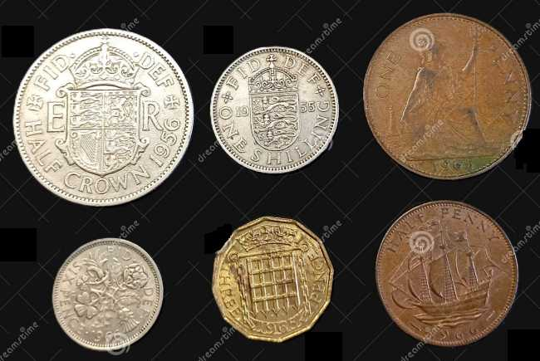
Old British Currency (until 1971)

Britain’s currency is based on the pound sterling (£).

Until 1971, the denominations were:
- 1 pound = 20 shillings (symbol ‘s’)
- 1 shilling = 12 pence (symbol ‘d’)

The old system was referred to as “LSD”:

- L or £ = libra (Latin for “pound”)
- s = solidus (a Roman coin)
- d = denarius (the Roman penny)

The word ‘penny’ is from old German ‘pfenig’.

Amounts could be written in different ways:

- 1s 6d = one shilling and six pence
- £2 3s 4d = two pounds, three shillings, and four pence
- £9 10/6 = nine pounds, ten shillings, and six pence
- £20.13.9 = twenty pounds, thirteen shillings, and nine pence
- £95/19/11 = ninety five pounds, nineteen shillings, and eleven pence
- 10/– = ten shillings
- 1/10/– = one pound and ten shillings

Coins in circulation:
- crown = 5 shillings
- half-crown = 2s 6d
- florin = 2 shillings
- shilling
- sixpence
- threepence
- penny
- half-penny
- farthing (= ¼ penny)

Paper notes in circulation:
- 10 shillings
- 1 pound
- 5 pounds
- 10 pounds
- 20 pounds
- 50 pounds

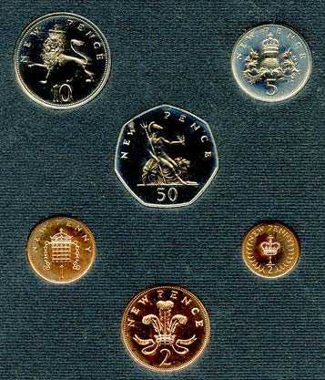
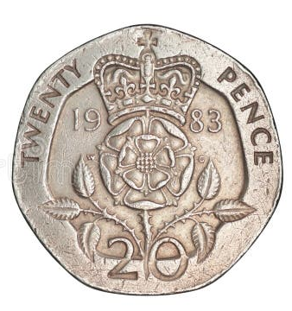
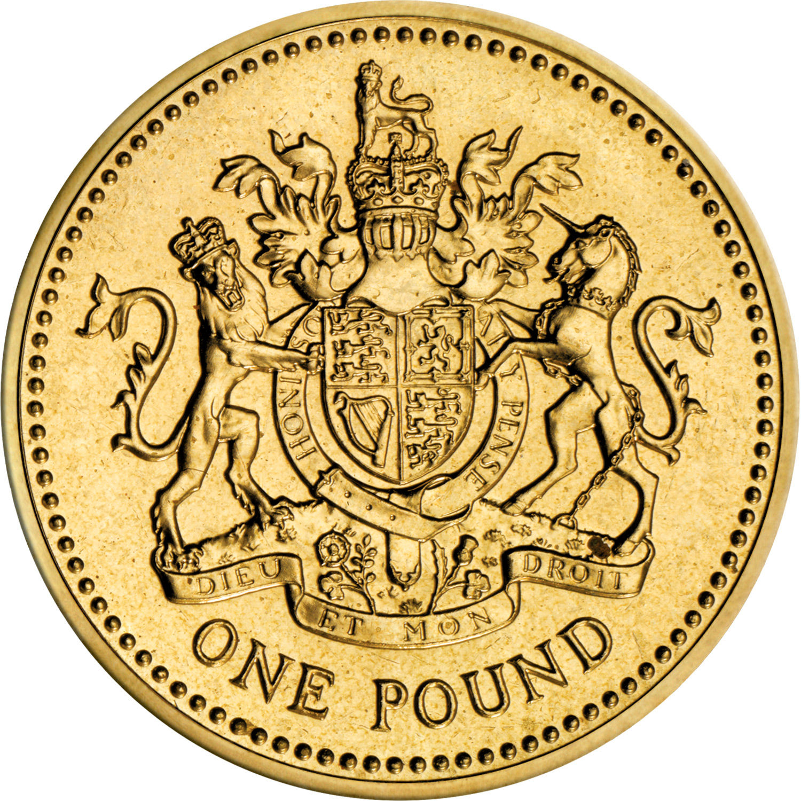
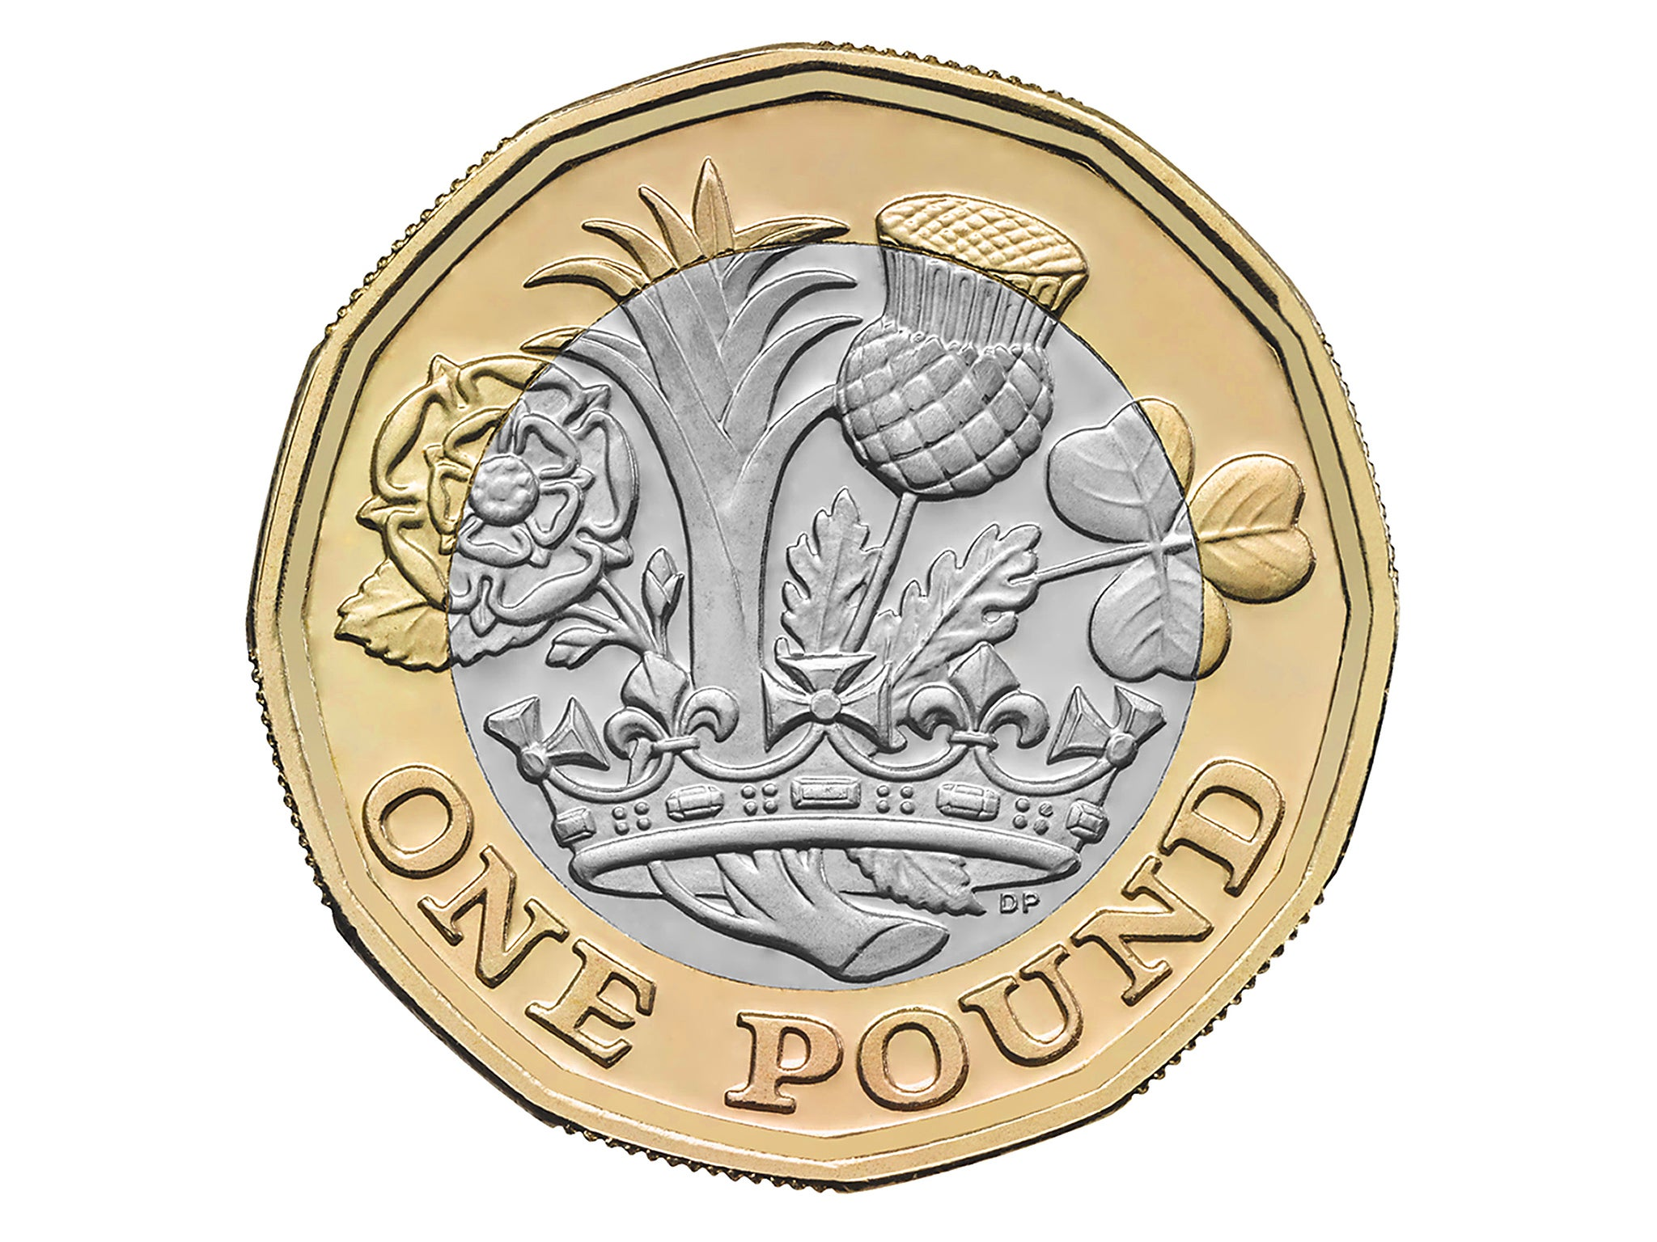
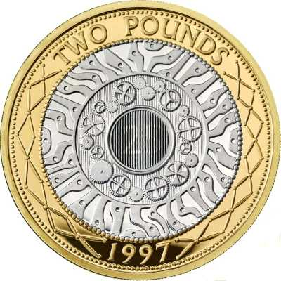
New British Currency (from 1971)

On 15 February 1971 (“Decimal Day”), the UK changed to a decimal currency system:

£1 = 100 new pence (p).
10p 5p

50p

1p ½p

2p

New coins:
- ½p
- 1p
- 2p
- 5p
- 10p
- 50p

In 1982, the 20p coin was introduced.
In 1983, the £1 coin was introduced,
replacing the £1 note.
In 1984, the ½p coin was phased out.
In 1998, the £2 coin was introduced.
In 2017, the £1 coin was reinvented.

So today, we have the coins:
- 1p
- 2p
- 5p
- 10p
- 20p
- 50p
- £1
- £2

and the notes:
- 5 pounds
- 10 pounds 20p
- 20 pounds
- 50 pounds 2 pounds

1 pound 1 pound (from 2017)

