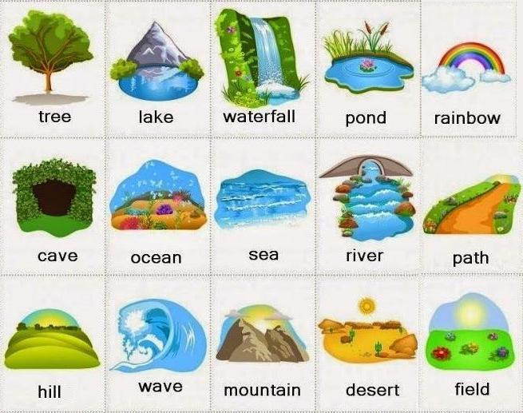
English Vocabulary - Nature

- animal – living creature (mammal, reptile, bird, fish, insect, etc.)
- bay – a curved part of the coast
- beach – a sandy area where water and land meet
- branch – part of the tree that grows from the trunk
- bush – a low thick growth of plants often used as a divider
- cave – underground rocky chamber
- clearing – open area in a forest
- cliff – a vertical rocky edge at the coast or in the mountains
- cloud – water vapor in the sky
- coast – the border between the land and the sea
- countryside – rural land
- desert – dry, sandy area with little vegetation
- Earth – the planet where we live
- field – an open area of land, often grassy
- flood – when an area is under water
- flowers – colorful plants
- forest – area with many trees and much vegetation
- grass – a natural green cover that grows in gardens, cities and the countryside
- hill – an area of land that is slightly raised
- island – an area of land that is surrounded by water
- jungle – dense, wild, hot, humid forest
- lake – water surrounded by land
- leaf – small green part of a plant or tree
- meadow – an open space that is grassy and often has wild flowers
- moon – the natural satellite that orbits Earth
- mountain – a very big hill
- path – area with little vegetation that is good to walk on
- plant – living organism that uses photosynthesis
- pond – a very small lake
- rain / raindrops – water that falls from the clouds
- rainbow – the coloured arch produced by rain and sun
- rainforest – a forest that receives a lot of rain
- river – long line of water that goes from the mountains to the sea
- rock – solid minerals that form the Earth’s surface
- sand – loose material that covers some beaches and deserts
- sea / ocean – the salt water that covers our planet
- seasons – summer, autumn(UK) / fall(USA), winter, spring
- sky – the blue atmosphere of the Earth
- soil – the red or brown layer where plants grow
- stars – hot balls of fire in space
- stone – a small rock
- sun – the star that heats our planet
- sunshine – the light and heat that come from the sun
- tree – big plant made from wood
- valley – an area of low land between mountains or hills
- volcano – mountain that erupts lava
- waterfall – where a river falls over rocks (USA: cataract)
- wave – a moving “hill” of water
- wild – area that is uninhabited by humans
- wildlife – all wild animals

