English Vocabulary: OK

The word “OK”, is an internationally-recognized word, and it can be a noun, a verb, an adjective, an adverb or an interjection! Spelling variations include:
- Okay
- O.K.
- OK

It can mean:
- Approval A: What do you think of the report? B: It’s OK.
- Permission A: Can I go out tonight? B: OK.
- Agreement A: So, let’s go to Paris for our honeymoon. B: OK.
- Consent A: So, it’s decided. We will purchase 100 computers. B: OK.
- Acknowledgment A: I’m going to the supermarket. See you later. B: OK.
- Indifference A: I’m not going to make dinner tonight. B: OK.
(often accompanied by a shrug of the shoulders)

The word is frequently used in many languages, and it is the most frequently spoken or written word in the world. The abbreviation “AOK” means “excellent” and was first used by space scientists in the USA, and it is still popular today in many parts of the USA.

Video: https://english.insl.com.br/files/videos/AOK.mp4 (short)

Grammar usage

1. Adjective. As an adjective, “OK” principally means "adequate" or "acceptable" as a contrast to "bad". It can also mean "mediocre" when used in contrast with "good".

- The report is OK, so you can send it.
- Your test was OK, but you need to study more.
- The burger was OK, but the fries were fantastic!
- The film was OK, but I won’t recommend it to my friends.
- A: Was dinner OK? B: Yes, it was OK.

2. Adverb. ‘OK’ can be an adverb, to say that an action was “acceptably performed”.

- Wow, you did OK for your first time skiing!
- You played OK, but I think that you should practise more.

3. Noun. ‘OK’ can mean "assent" when used as a noun.

- The boss gave his OK to the purchase.
- When I asked my manager if I could take a vacation, she replied with an OK.

4. Interjection. As an interjection, ‘OK’ can mean compliance, agreement or acknowledgement.

- OK, I’ll do that.
- OK, that’s fine.
- OK. Understood.

‘OK’ can also be used to ask for confirmation.

- I’ll use 3 eggs for your omelet. OK?

5. Verb. “OK” means “to authorize an action” but it’s an informal way to speak English. It is treated as a regular verb: to OK / OKed / OKed or to okay / okayed / okayed

- The boss OKed the purchase.
- Did you OK the purchase?
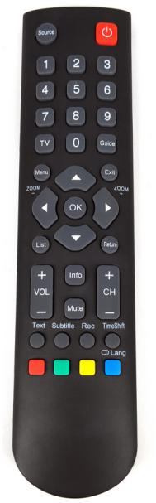
History/Origin

The origin of the word is disputed. Here are 4 possibilities:

1) In the year 1840 in the USA, during his re-election campaign, President Van Buren’s supporters invented a motto – “O.K.”, from his nickname “Old Kinderhook”, because he was born in the town of Kinderhook, in the New York state.

2) In the 1830s in Boston newspapers, the abbreviation “o.k.” was used to mean “all correct”. This was an attempt at humour - deliberately misspell words and abbreviate them. For example:

- OK Oll Korrect (All Correct)
- OW Oll Wright (All Right)
- KG Know Go (No Go)

3) The Choctaw (an indigenous North American language) word: ”okeh" which means "it is so".

4) The Scottish phrase "och aye" which means "oh yes".

Signs/Gestures
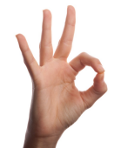


Technology

Many websites and programs require the user to
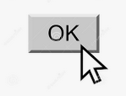
click on an “OK” button:

Also, many electronic devices have an “OK button”.

Recommended video:
https://www.youtube.com/watch?v=GyVSj3KNGCQ (4 mins)

