English Vocabulary – Professions

 |  | 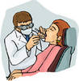 | 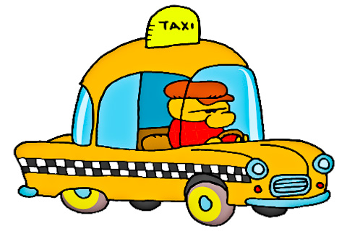 |  | 
1. ________ | 2. ________ | 3. ________ | 4. ________ | 5. ________ | 6. ________
  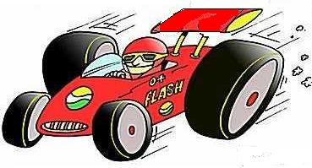 |  | 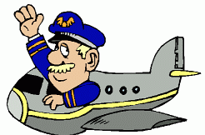 |  | 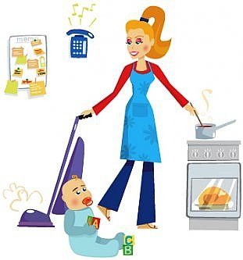 | 
7. ________ | 8. ________ | 9. ________ | 10. ________ | 11. ________ | 12. ________

What do you do? I'm a/an _____________________.
What does he do? He's a/an ____________________.
What does she do? She's a/an ____________________.

