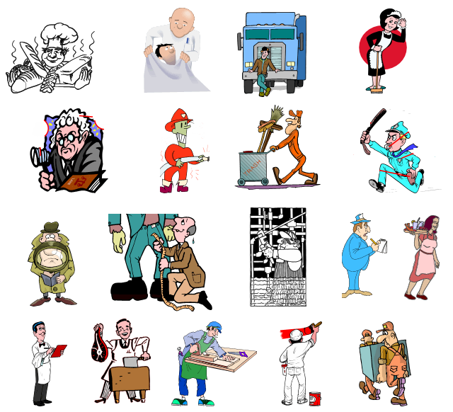
English Vocabulary – Professions

Name the professions:

1. ______________ 7. ______________ 13. ______________
2. ______________ 8. ______________ 14. ______________
3. ______________ 9. ______________ 15. ______________
4. ______________ 10. ______________ 16. ______________
5. ______________ 11. ______________ 17. ______________
6. ______________ 12. ______________ 18. ______________

