English Vocabulary – Relationships

 |  |  | 
to have a crush on someone | boyfriend/girlfriend,  sweetheart, lover  single/bachelor | date, blind date,  to date,  to see someone,  to go on a date | to fall in love,  to be in love,  love at first sight
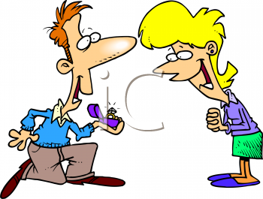 |  |   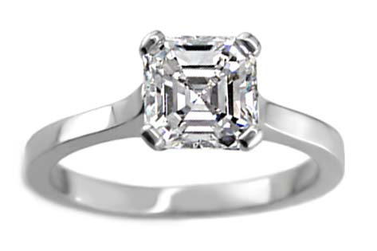 |   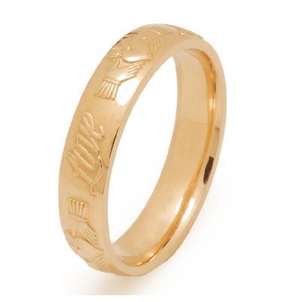
fiancé(M)/fiancée(F)  to propose to,  to get engaged to | bride,  groom | engagement ring,  wedding ring | wedding (noun),  to marry,  to get married
 |  | 
married (adj),  marriage (noun),  wife/husband | to cheat on someone | to break up,  to separate,  to divorce

Civil Status (official)
- single
- married
- common law relationship
- divorced
- widowed

Other Status (unofficial)
- friends
- friends with benefits
- dating
- engaged
- separated


The Vocabulary of Love
love o amor
to love amar
passion paixão
passionate apaixonado
foreplay preliminares
to make love fazer amor
to feel love for someone sentir amor por alguém
lover amante
marriage casamento (estado)
wedding casamento (a cerimônia)
fiancée / fiancé noiva / noivo (antes do casamento)
bride / groom noiva / noivo (somente no dia da cerimônia)
wife / husband esposa / marido (spouse)
engagement noivado
to get engaged ficar noivo(a)
to fall in love apaixonar-se
to fall out of love não estar mais apaixonado
love at first sight amor à primeira vista
to be in love estar apaixonado
to have an affair ter um caso
torrid affair caso tórrido
to make out (Amer. Eng.) beijar

A love story:
“I feel a lot of love for Mary. I have felt love for her for many years. In fact, we fell in love with each other immediately. It was love at first sight! I had never fallen in love like that before. She is the only person with who I have fallen in love! I have never felt love so strongly! We are still in love today. I think that we will never fall out of love.”
Exercise. Translate to Portuguese:
1. Travel is my passion!
__________________________________________________________________
2. He is a passionate lover.
__________________________________________________________________
3. Maria got engaged to Johnny yesterday!
__________________________________________________________________
4. I love to love, and I hate to hate.
__________________________________________________________________
5. She fell in love with him immediately.
__________________________________________________________________
6. When she saw him, it was love at first sight.
__________________________________________________________________
7. I have been in love with her since the day we met.
__________________________________________________________________
8. Harold had many affairs throughout his marriage.
__________________________________________________________________
9. They make out in the park every evening.
__________________________________________________________________
10. They fell out of love after only three weeks of marriage.
__________________________________________________________________

