English Vocabulary: Every____ / Some____ / Any____ / No____

 | Person  (pessoa) | Thing  (coisa) | Place  (lugar) | Time  (tempo/hora) | Method  (jeito/maneira)
every  (100%) | everybody / everyone  (todo mundo) | everything  (tudo) | everywhere / every place  (em todo lugar) | every time (= always)  (toda vez / todas as vezes) | every way  (todo jeito)
some  (1) | somebody / someone  (alguém) | something  (alguma coisa) | somewhere / some place  (em algum lugar) | sometime  (em algum momento) | somehow / someway  (de alguma maneira / por alguma razão)
any  (1) | anybody / anyone  (qualquer pessoa) | anything  (qualquer coisa) | anywhere / any place  (em qualquer lugar) | anytime  (em/a qualquer momento) | anyhow / anyway  (de qualquer jeito / maneira / forma)
no  (0%) | nobody / no-one  (ninguém) | nothing  (nada) | nowhere / no place  (em nenhum lugar) | no time (= never)  (em nenhum momento / nunca) | no way  (de jeito nenhum)

A Funny Story
Once upon a time, there were four people. Their names were Everybody, Somebody, Nobody and Anybody.
When there was an important job to be done, Everybody was sure that Somebody would do it. Anybody could do it, but Nobody did it.
When Nobody did it, Everybody got angry. Everybody thought that Somebody would do it, but Nobody realized that it wouldn't be done.
Consequently, Everybody blamed Somebody when Nobody did what Anybody could have done.
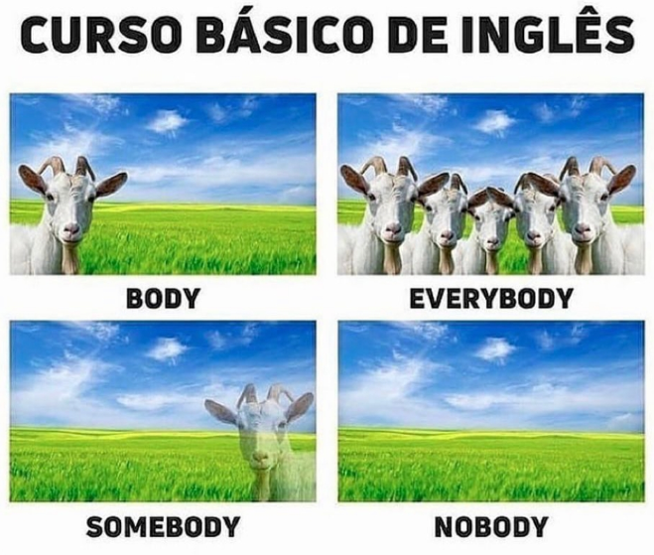  Note that all of these words are “third person singular”:  - Everybody drinks water.  - Everything is awesome.  - Nowhere is safe.  - Nothing is certain.  - Anything is OK for me.  - Something is stuck to my shoe.  - Does anybody have a pen? | The word "any" has two possible contexts:  1) "any"="undefined quantity" in negative sentences and questions  Examples: I don't have any money.  Do you have any money?  2) "any" = “random choice” (PT: qualquer)  Example: A: Which cake would you like?  B: Any one is OK for me.

Exercise. Complete the following using the words from the table on Page 1.

1. _______________ remembers my name except you !
2. Can you please give me ___________________ to drink?
3. I’m so lonely. I have _________________ to go, and __________________ to go with me.
4. a. My pockets are empty. I don’t have __________________ in them.
b. My pockets are empty. I have __________________ in them.
5. Come and visit me _______________. My family would love to see you.
6. __________________________ I smell flowers, I sneeze.
7. Can ______________________ help me, please? I’m stuck!
8. If there’s _____________________ that I can do for you, please tell me.
9. I’ve visited every country in the world. I’ve been ___________________ !
10. I will find ___________________ to help him. He is my brother.
11. I need a drink. I don't care what it is! __________________ !

