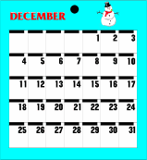
English Vocabulary – Time

1) Periods of time
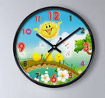
- second
- minute
- hour
- day
- week
- fortnight (= fourteen nights)
- month
Calendar
- trimester (= 3 months)
Clock
- semester (= 6 months)
- season (fall, winter, spring, summer)
- year
- decade
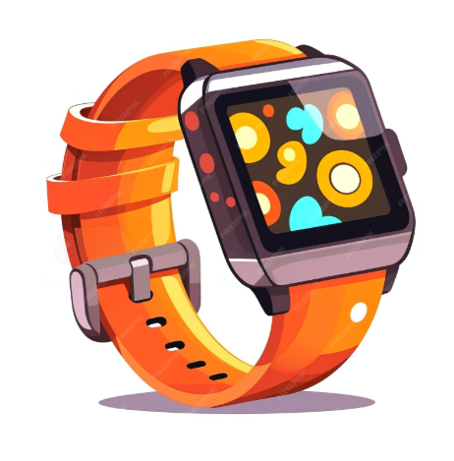
- century

- millennium (plural: millennia)

2) Times of the day
- dawn / sunrise
- morning / forenoon (= before midday)
- midday / noon
- afternoon (= after midday)
- dusk / sunset
Watch
- evening
Smartwatch
- midnight
- night

3) Days

3 days ago | the day before yesterday | yesterday | today | tomorrow | the day  after tomorrow | in 3 days

Note: We use “last” to refer to days occurring last week.
We use “this” to refer to days occurring this week.
We use “next” to refer to days occurring next week.

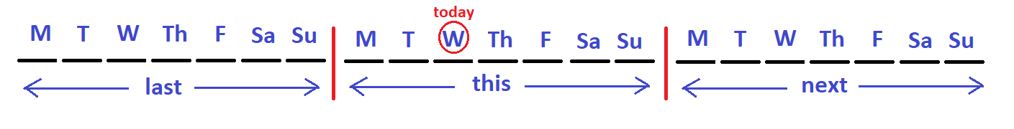

4) Weeks/Weekends/Months/Years:

3 ____ ago | the ____  before last | last ____ | this ____ | next ____ | the ____  after next | in 3 ____

5) Arriving
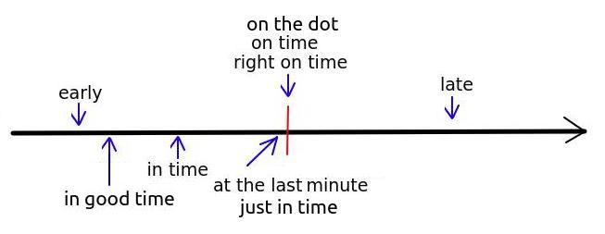

6) Time Expressions

Muitas vezes  Mais uma vez  Ele adiantou a reunião  Estou adiantado / cedo  Ele atrasou a reunião  Estou atrasado  Daqui a pouco  Em breve  No futuro distante  Há um tempo atrás  Muito tempo atrás  Vou passar um tempo em Londres  Vamos dar um tempo  Sem pressa / Tranquilo  A hora está chegando  A hora nunca chega  O tempo não passa  O tempo não passa nunca  O tempo voa  Eram tempos difíceis  Tempo para economizar  Tempo de vacas gordas  Tempo de vacas magras  No momento apropriado  Seu timing foi perfeito.  Essa loja parece ter parado no tempo  De um tempo para cá / Faz um tempo | Many times  One more time  He advanced the meeting  I'm early  He delayed the meeting  I'm late  In a while  Soon  In the distant future  A while ago  A long time ago  I will spend some time in London  Let's take a break  Take your time  The time is coming  The time never comes  Time doesn't seem to pass  Time never passes  The time flies  They were hard times  Time to save  Fat times / Fat years  Lean times / Lean years  At the appropriate time  Your timing was perfect  This store seems to be frozen in time  For some time

Exercise. Complete the following with appropriate vocabulary:
1. My favourite season is ___________. I love cold weather!
2. I go to work at 8 o’clock in the ___________ and come home at 5 o’clock in the ___________.
3. He works very long hours – from ___________ to ___________. He never sees the sun!
4. I was born in the 1980s – the best ___________ for music, in my opinion!
5. My aunt has lived for more than a ___________. She is 101 years old.
6. The dinosaurs have been extinct for many ___________.
7. I always wear a ___________ when I go to work, so I never miss a meeting!
8. My boss uses her ___________ to make a note of all her meetings.
9. I want to go to Europe ____________________. (2029)
10. What time did you get up ___________ morning? (today)

Teaching Time (funny): https://www.youtube.com/watch?v=0QVPUIRGthI (6 mins)

Before digital clocks, we had other ways to tell the time:
13:50 Ten to two
14:10 Two ten / Ten past two
13:45 Quarter to two
14:15 Quarter past two
14:30 Half past two
English – Military Time
English uses a 12-hour clock (a.m. and p.m.), but the British and American military use a 24-hour clock, which starts at “0000” and finishes at “2400” (which are both midnight). See image below.
This is how we say exact hours:

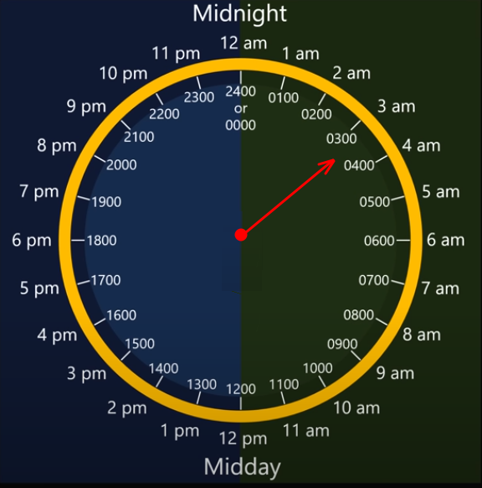
0000 Zero hundred hours
0200 Oh two hundred hours
0600 Oh six hundred hours
1200 Twelve hundred hours
1600 Sixteen hundred hours
2000 Twenty hundred hours
2400 Twenty four hundred hours

Other times are said as follows:

0215 Oh two fifteen
0630 Oh six thirty
0810 Oh eight ten
0905 Oh nine oh five
or Nine oh five
1325 thirteen twenty five
1750 Seventeen fifty
2105 Twenty one oh five
2345 Twenty three forty five

The British military use “2359” (twenty three fifty nine) instead of “2400” (twenty four hundred hours), which means that the clock starts at “0000” (midnight) and finishes at “2359” (one minute before midnight). The reason for this is to distinguish between days or dates. For example, if your commander says:

“Meet me at 2400 on Monday”

is he talking about Sunday night or Monday night? But if he says:

“Meet me at 2359 on Monday”

then it is clear that he is talking about Monday night.

