Vocabulary – Tools
Source: www.vocabularypage.com
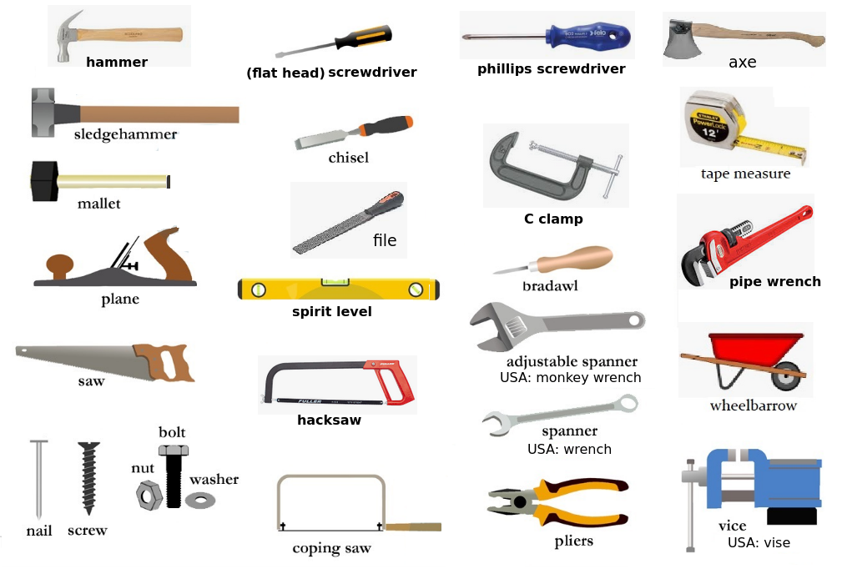
Building supplies / Building material

building supplies store – loja de materiais de construção  brick – tijolo  concrete – concreto (concrete block – bloco de concreto)  cement – cimento  bulb / light bulb – lâmpada  fabric / cloth – tecido  clay – argila  wood – madeira  stone – pedra  sand – areia  glass – vidro  ceiling – teto / forro, roof – telhado  tile – telha, floor tile – ladrilho, wall tile - azulejo  floor – chão / piso  iron – ferro  steel – aço  stainless steel – inox  lead – chumbo  socket (UK) / outlet (USA) – tomada  plug – plug  porcelain – porcelanato  wire – fio / arame  pipe – cano | nail – prego  washer – arruela  nut - porca  screw – parafuso  wood screw - parafuso para madeira  drill bit – broca, drill chuck – mandril  tape measure – trena  hook – gancho  blade – lâmina  extension cord – extensão  electrical tape – fita isolante  thread seal tape – fita veda rosca  masking tape – fita crepe  fittings – conexões  duct tape – fita de vedação  sandpaper – lixa  Power tools:  electric drill – furadeira elétrica  power sander – lixadeira elétrica  circular saw – serra circular  jigsaw – serra tico-tico (serra de vaivém)  electric screwdriver – parafusadeira

