English Vocabulary - Transport
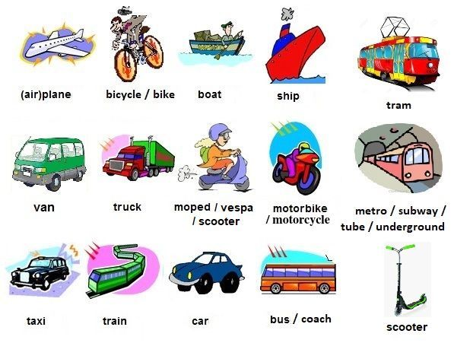

How do we go?
by plane
by car
by taxi
by bus
by ship
by train

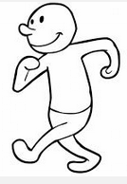

on foot (walk)
Questions about buses and trains:
- Can you tell me the time of the next train to Chicago, please?
- Is it direct?
- Is there a restaurant car? (train only)
- What platform does it leave from?
- What time does it leave?
- What time does it arrive?
- How long is the journey?
Questions about flying:
- How much is a flight to New York?
- Is it a direct flight?
- Is food served?
- Which terminal does it leave from? / Which gate does it leave from?
- I would like a window seat, please. / I would like an aisle seat, please.
- What time must I check in?
- What time does it take off?
- What time does it land?
- How long is the flight?
Buying a bus ticket:
A: I'd like a ticket to San Francisco, please.
B: Single or return?
A: Return. How much is it?
B: It’s $30 peak time, or $25 off-peak.
A: What times are off-peak?
B: Between 10am and 3pm.
A: OK. I'll travel off-peak then, thanks. Can I reserve a seat?
B: Yes, but it's an extra $5.
A: Is it direct or are there any connections?
B: It’s direct. No connections.
A: Great. What is the time of the first off-peak bus?
B: 11:30.
A: Thanks very much. Here is the money.
B: Here is your ticket. Your seat is 16A. Have a good trip.
A: Thanks. Bye.

